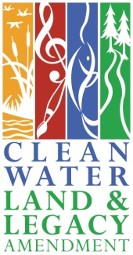
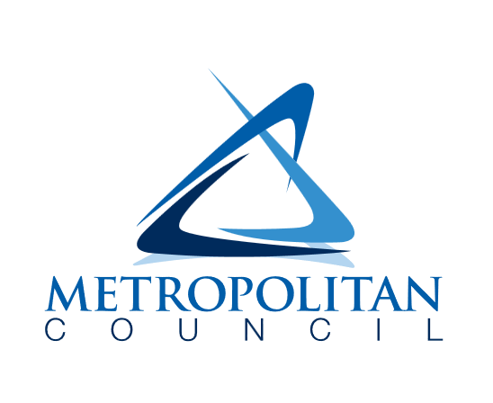
2026 – 2028
Metropolitan council water efficiency grant program

frequently asked questions
updated 03 / 05 / 2026

For detailed information about the 2026-2028 Water Efficiency Grant Program, please refer to the program guidelines document. This FAQ document may be updated as new questions arise.

For Municipalities
- I missed the application window for this program, can I still participate?
  - Unfortunately, it’s not possible to participate in the current grant cycle if your municipality did not apply and receive an award during the application and award announcement period. If your city is interested in future grant opportunities and would like to be contacted, please fill out this interest form.
- How do I know if a product is WaterSense or Energy Star labeled?
  - To verify the eligibility of a grant activity, please refer to the WaterSense Product Search and Energy Star Product Finder web pages. These pages also include Excel file versions of product lists. Retailer websites may not be fully up to date – please refer to the WaterSense and Energy Star websites for the definitive lists of eligible grant activities.
- Our city would like to purchase a bulk order of toilets and sell them to residents at a reduced cost, is this possible for our program or does it have to be a rebate program?
  - Yes, participating municipalities may elect to make bulk purchase of devices and sell them to residents/businesses, as long as the requirements around device eligibility, municipality match, and portion of the cost paid by the property owner are followed. For additional detail, reach out to Met Council staff.
- Our program has been very popular and we’ve used up (or will soon use up) our award, can we apply for additional funds?
  - Yes, participating municipalities can submit and amendment form to the Met Council (found at the end of the Grant Agreement). Met Council staff will review the form, the municipality’s spending, and complete the amendment if there are available funds.

For Residents
- How do I participate in this program?
  - To participate in this program, the first step is to check whether the municipality you are in is participating in the Water Efficiency Grant Program. You must be a customer of the water utility. If the municipality you are in does have a program, visit their website for more information about eligible expenses, important dates, and other requirements. The Metropolitan Council does not directly issue rebates or grants to residents.
- The city that I live in does not have a rebate program, can I still participate?
  - Unfortunately, if the city that you live in does not have a program then it will not be possible for you to participate in this cycle of the Water Efficiency Grant Program. Residents may be interested in contacting their city staff to encourage them to apply for future grant cycles.
- I want to get rid of my lawn and replace it with drought-tolerant landscaping, can I get funding from this program?
  - The Metropolitan Council’s Water Efficiency Grant Program does not offer funding for turfgrass conversion on residential properties. The Lawns to Legumes program may be a good resource to learn more about.
- I submitted a rebate application to the city I live in, but it was rejected because the device/grant activity wasn’t purchased during the program dates, can I get any money back through this program?
  - This program is intended to provide incentives to residents to purchase eligible devices (or audits). Purchases made before the program dates are unfortunately not eligible for reimbursement by the Met Council.
- How do I know if a product is WaterSense or Energy Star labeled?
  - To verify the eligibility of a grant activity, please refer to the WaterSense Product Search and Energy Star Product Finder web pages. These pages also include Excel file versions of product lists. Retailer websites may not be fully up to date – please refer to the WaterSense and Energy Star websites for the definitive lists of eligible grant activities.

For Businesses
- How do I participate in this program?
  - To participate in this program, the first step is to check whether the municipality your business is located in is participating in the Water Efficiency Grant Program. You must be a customer of the water utility. If the municipality you are in does have a program, visit their website for more information about eligible expenses, important dates, and other requirements. The Metropolitan Council does not directly issue rebates or grants to businesses.
- The city that my business is in does not have a rebate program, can I still participate?
  - Unfortunately, if the city that your business is in does not have a program then it will not be possible for you to participate in this cycle of the Water Efficiency Grant Program. Businesses may be interested in contacting their city staff to encourage them to apply for future grant cycles.
- I want to get rid of my lawn and replace it with drought-tolerant landscaping, can I get funding from this program?
  - The Metropolitan Council’s Water Efficiency Grant Program does not offer funding for turfgrass conversion on commercial properties.
- How do I know if a product is WaterSense or Energy Star labeled?
  - To verify the eligibility of a grant activity, please refer to the WaterSense Product Search and Energy Star Product Finder web pages. These pages also include Excel file versions of product lists. Retailer websites may not be fully up to date – please refer to the WaterSense and Energy Star websites for the definitive lists of eligible grant activities.

