regional parks and Trails system COMPETITIVE equity grant PROGRAM
2027 Notice of Funding Availability
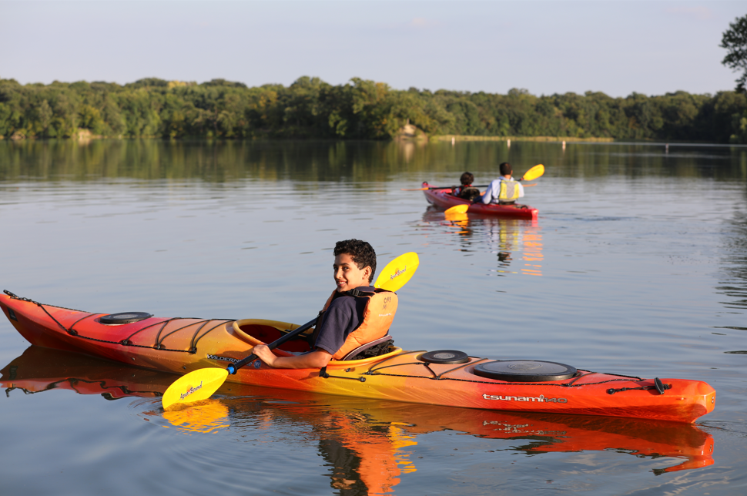

The Council’s mission is to foster
efficient and economic growth for
a prosperous metropolitan region
Metropolitan Council Members
Robin Hutcheson Chair  Judy Johnson District 1  Reva Chamblis District 2  Dr. Tyronne Carter District 3  Deb Barber District 4  John Pacheco Jr. District 5  Robert Lilligren District 6  Yassin Osman District 7  Anjuli Cameron District 8 | Diego Morales District 9  Peter Lindstrom District 10  Dr. Gail Cederberg District 11  Mark Jenkins District 12  Chai Lee District 13  W. Toni Carter District 14  Victor Obisakin District 15  Wendy Wulff District 16

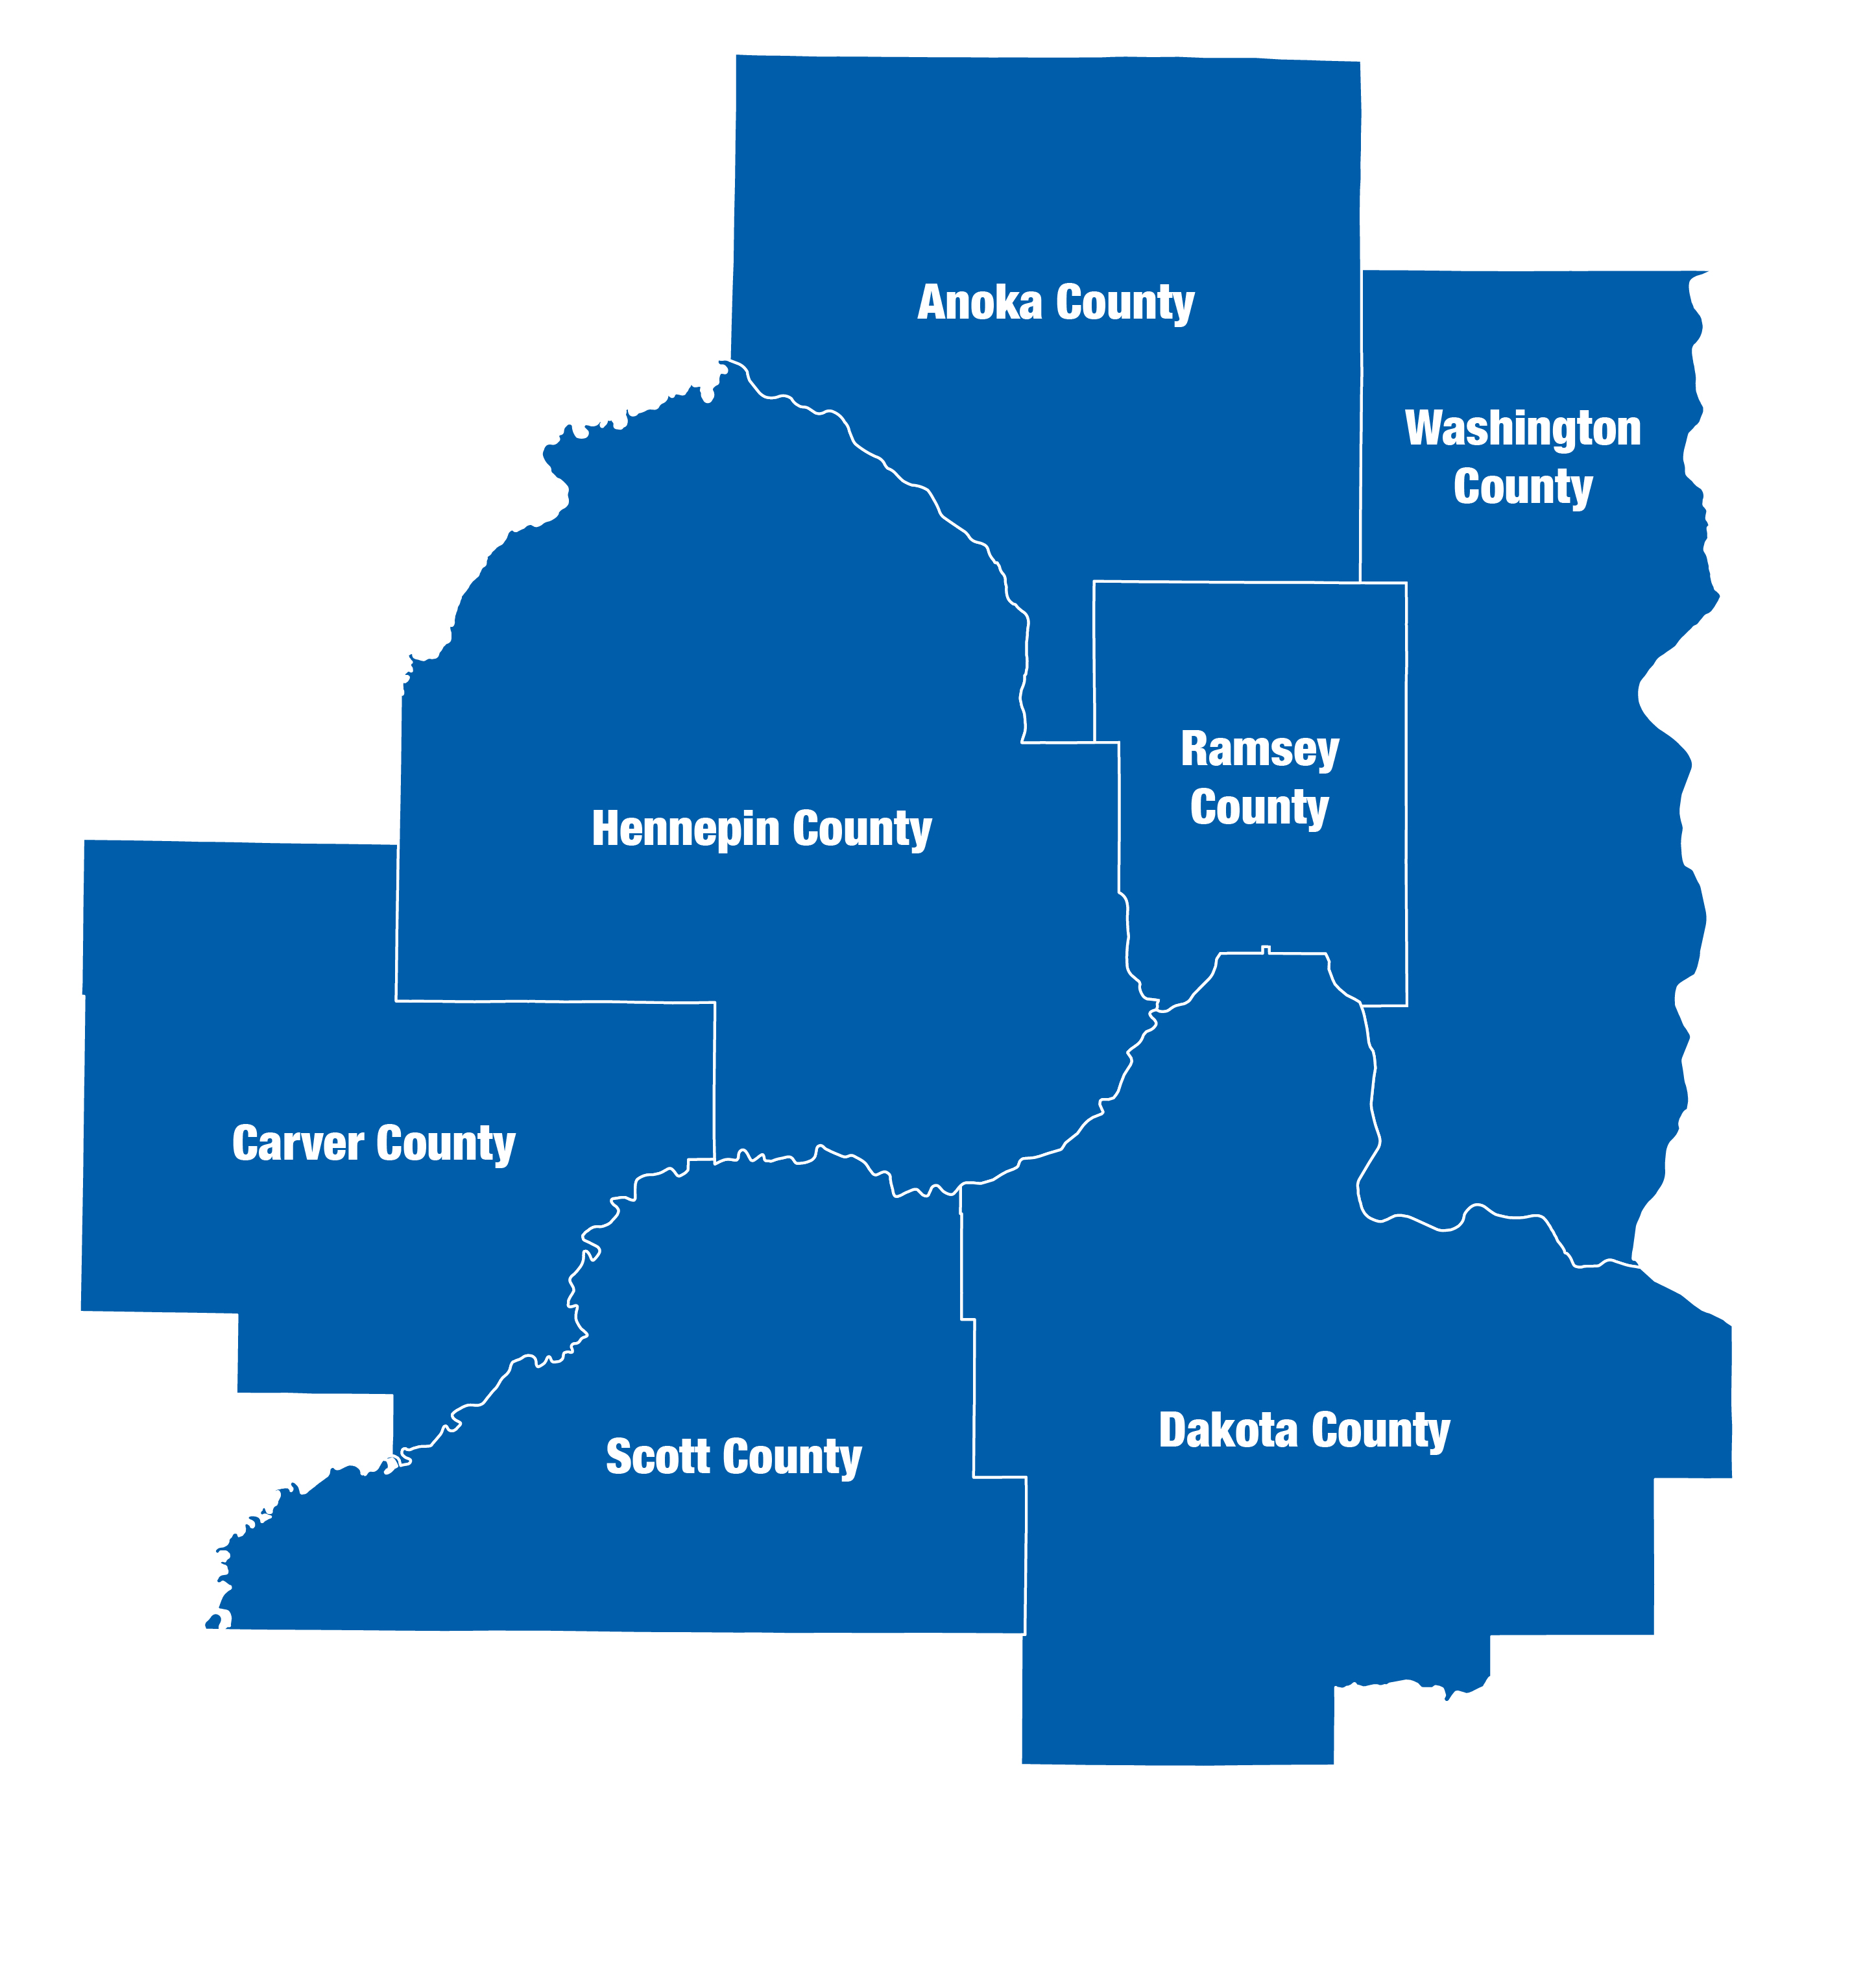
The Metropolitan Council is the regional planning organization
for the seven-county Twin Cities area. The Council operates the regional bus and rail system, collects and treats wastewater, coordinates regional water resources, plans and helps fund regional parks, and administers federal funds that provide housing opportunities for low- and moderate-income individuals and families. The 17-member Council board is appointed by and serves at the pleasure of the governor.
On request, this publication will be made available in alternative formats to people with disabilities. Call Metropolitan Council information at 651-602-1140 or TTY 651-291-0904.

2027 Notice of Funding Availability (NOFA)
This 2027 Notice of Funding Availability (NOFA) describes the Metropolitan Council’s intentions for the Regional Parks and Trails System Competitive Equity Grant Program in 2027. Specifically, this notice:
- Establishes the amount and type of funding available for the 2027 award year and the limits that apply to individual awards.
- Sets the schedule for application submittal, review and award.
- Describes the criteria the Metropolitan Council will use in project selection.
- Defines who is eligible to apply.

Background and History
Under Minnesota Statute 473.145, the Metropolitan Council is responsible for preparing a comprehensive development guide for the seven-county Twin Cities metropolitan area. The Council's Thrive MSP 2040 (Thrive) committed the Met Council to strengthening equitable usage of regional parks and trails by all our region’s residents across age, race, ethnicity, income, national origin, and ability. To honor this commitment, the Met Council created and implemented the regional parks and trails system competitive equity grant program in 2019 with a pilot program using Council bonds to fund capital projects. Additional funding was dedicated for the 2021 and 2024 grant cycles using parks interest earnings to fund programming and noncapital projects in addition to capital projects. The Council’s Imagine 2050 and the 2050 Regional Parks and Trails Policy Plan continue this commitment to equity and the equity grant program.
For more information about Regional Parks and Trails System use, visitor demographic information, or past engagement processes, refer to Regional Park Use Among Select Communities of Color (2014), 2021 Regional Parks and Trails System Visitor Study Report, the Regional Parks Policy Plan Update Community Engagement Summary 2018 and the Youth and Parks Research Study.

Purpose
The Council has designated a portion of its regional parks bonds and park interest earnings to provide financial support to regional park implementing agencies for projects that will strengthen equitable usage of regional parks and trails by all our region's residents, such as across age, race, ethnicity, income, national origin, and ability. Partnerships and engagement are necessary to shape the proposed projects, and as a result of this collaboration the Competitive Equity Grant Program will enhance institutional capacity around equity work across the Regional Parks and Trails System and with the Council and individual implementing agencies.
All proposals must address one or more of the following equity focus areas:
- Age
- Race
- Ethnicity
- Income
- National Origin
- Ability

Eligible Applicants
By state statute, applicants must be a regional park implementing agency, defined as the counties of Anoka, Carver, Dakota, Ramsey, Scott and Washington, the cities of Saint Paul and Bloomington, the Minneapolis Park and Recreation Board and the Three Rivers Park District. Regional park implementing agencies are welcome to collaborate on proposals. Individuals and/or other governmental, private, or nonprofit entities are not eligible to apply, but are encouraged to be included as project partners with regional park implementing agencies.
As a condition for participating in this grant program, applicants must either have, or be substantially working towards, completing a current Americans with Disabilities Act (ADA) self-evaluation or transition plan that covers accessibility to the Regional Parks and Trails System as required under Title II of the ADA.

Available Funds and Award Limits for 2027
- $1,000,000 in Council capital bonds is available for competitive capital projects.
- $7,000,000 in Parks Interest Earnings is available for competitive non-capital and capital projects.
  - High-quality non-capital projects will be prioritized; any remaining funds will be available for capital projects.
  - Parks interest earnings may be used to pay for engagement and outreach included in a capital project.
- Agencies may submit up to four applications.
  - Multi-agency applications do not count towards the individual agency cap
- No individual grant shall be less than $100,000 or more than $1,000,000
- The Council will seek to maintain a geographical balance in distributing funds.
- If an Agency receives multiple grants, Council staff reserve the right to combine them as appropriate into one grant agreement.
- The Council reserves the right to award less than the available funding.
- The Council reserves the right to award less than the amount requested and will negotiate any necessary revisions in project scope prior to finalizing a grant agreement.
- The Council will only consider funding proposals that meet all the required eligibility criteria and receive at least 50 of the 100 potential points.
- Grants are reimbursement-based.

Eligible Uses of Funds
Consistent with authorizing state statutes and the 2050 Regional Parks and Trails Policy Plan, grant proposals must meet all of the below criteria to be considered for funding:
- Address one or more of the equity focus areas outlined above (age, race, ethnicity, income, national origin or ability);
- Be within the boundaries of the Regional Parks and Trails System or clearly connect visitors to the regional parks and trails within the Regional Parks and Trails System;
- Be consistent with the 2050 Regional Parks and Trails Policy Plan;
- Be broadly consistent with a Council-approved long-range plan prior to the Council executing a grant agreement;
- Be compliant with the Americans with Disabilities Act (ADA).
- Be approved by the Agency’s locally elected board either individually or as part of a local capital improvement plan prior to the Council executing a grant agreement.
- For capital funds only, be capital in nature, including real property, personal property, or equipment used in Regional Parks and Trails System operations with an estimated useful life of more than one year and with an initial cost of $10,000 or more:
  - Capital assets may be either intangible (e.g. easements, water rights) or tangible (e.g. land, buildings, building improvements, vehicles, machinery, equipment, and infrastructure).
  - Private use of the capital asset is not allowed as any private use can jeopardize the tax-exempt status of the bonds.
Applicants are encouraged to think broadly about their project proposals and are invited to contact Council staff with any and all questions about potential eligible uses of funds.

Example Proposals
The following examples are meant to spark imagination rather than limit thinking. Applicants are encouraged to examine and understand their community needs to develop project proposals that meet the spirit of this funding.
- Collaborative efforts among multiple regional park implementing agencies to develop shared knowledge and approaches to identified capital projects or programming efforts to advance equitable usage.
  - Examples could include a system-wide marketing plan, system-wide signage, purchasing a shared bike fleet for outreach or education programming, or purchasing a mobile classroom to share across the agencies.
- Partnerships between a regional park implementing agency and a community-led effort to identify and produce a capital project or non-capital programming effort.
  - May include contracting with a nonprofit organization or private consultant to develop and initiate equity programming efforts.
- New equity programming efforts including outreach, education, marketing, external communications, special events, translation and interpretation services, staff training, and hiring new staff to develop and implement equity efforts
- Innovative or new capital projects, built on existing partnerships, that will advance accessibility and provide a meaningful experience to users with disabilities such as cognitive, physical, visionary, or auditory.
- Multidimension equity efforts that incorporate public art, climate change, or environmental justice.

Funding Schedule
October 2026 Notice of funding availability posted and Fluxx open for applications
November 2026 Applications due by 4:00 P.M. on November 30, 2026
January 2027 Review committee meets to score and recommend projects
February 2027 Metropolitan Parks and Open Space Commission recommends project selections
February 2027 Community Development Committee recommends project selections
February 2027 Council approves project selections
March 2027 Grant agreements initiated
These dates are subject to change.

Proposal Review Process
Council staff will review all proposals to ensure completeness and eligibility. Council staff are available to answer agency questions throughout the application process.
A review team will score the proposals and make recommendations for funding to the Council. The review team will be comprised of up to four members of the Metropolitan Parks and Open Space Commission, up to three Council members who serve on the Community Development Committee, up to three representatives from the implementing agencies, and up to two members from the Council’s Equity Advisory Committee. Members of the review team shall be asked to recuse themselves from scoring or commenting on any applications for which they have a real or perceived conflict of interest.

Grant Terms
Grants will have a three-year term with a one-year extension possible at the discretion of Council staff. In rare circumstances, an additional extension may be possible. All costs eligible for reimbursement must be incurred during the grant term, as amended, and all costs must be submitted within 90 days after the end of the grant term. Unspent grant funds will revert to the Council.

Project and Program Evaluation
The Council will review the impact of funded projects and the efficacy of the Council’s program application processes regularly with a desire to continually improve both. Evaluation results will inform future funding rounds.

Competitive Scoring Criteria
Evaluation Criteria | Points
Impact on equitable use:  - The proposal clearly identifies one or more underserved populations that the project will benefit, why they were chosen, and proposed outcomes  - The proposal responds to a need demonstrated through previous community engagement and/or long-range planning | 20
Community partnerships:  - The proposal demonstrates community involvement throughout the project by both developing new relationships and strengthening existing partnerships  - The proposal demonstrates how partnerships will continue after the grant period | 20
Community engagement and awareness:  - The proposal demonstrates how partners and underserved populations will be engaged throughout the project and after the grant period  - The proposal includes regional parks and trails system awareness building among underserved communities | 20
Capacity building:  - The proposal will increase the ability of the regional park implementing agencies and their partners to grow their skills in working with underserved communities  - The proposal demonstrates the agency’s capacity to leverage the Council’s funds through non-state funds, grants, or in-kind contributions and/or the ability to continue the work after the grant period is complete | 20
Programming initiatives:  - The proposal describes the internal process used to identify and develop the project and it describes the agency’s outreach/education staff involvement when applicable  - The proposal clearly demonstrates how new programming efforts will affect underserved populations | 20
Total Possible Points | 100
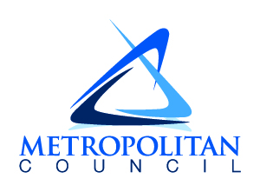
390 Robert Street North
Saint Paul, MN 55101-1805
651.602.1000
TTY 651.291.0904
public.info@metc.state.mn.us
metrocouncil.org
Follow us on:
twitter.com/metcouncilnews
facebook.com/MetropolitanCouncil
youtube.com/MetropolitanCouncil


Minn. Stat. § 473.315: https://www.revisor.mn.gov/statutes/?id=473.315
Minn. Stat. § 473.351: https://www.revisor.mn.gov/statutes/?id=473.351
The 2050 Regional Parks and Trails Policy Plan is available at: https://metrocouncil.org/Planning/Imagine-2050/Policy-Plan-Index/Imagine-2050-Accessible-PDFs/2050-Regional-Parks-and-Trails-Policy-Plan.aspx

