
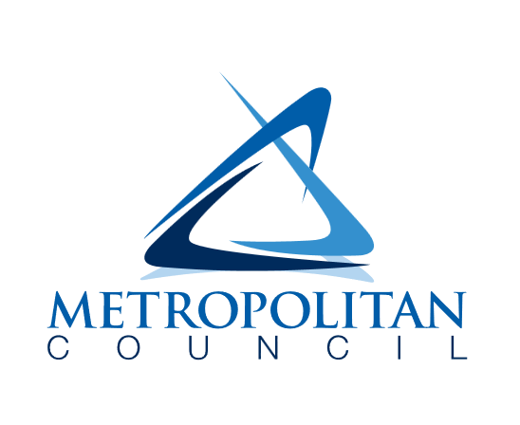

2026 – 2028
Metropolitan council water efficiency grant program
application form
updated 02 / 25 / 2026

Applicant information:
MUNICIPALITY:
MUNICIPAL UTILITY:
MAILING ADDRESS:

Primary contact information:
Municipality primary authorized representative (all correspondence regarding the Water Efficiency Grant Program should be addressed to individual named below):
Name:
Title:
Phone:
Email:
Mailing Address:

Secondary contact information:
Municipality secondary authorized representative:
Name:
Title:
Phone:
Email:
Mailing Address:

Water use information:
Municipal Total Per Capita Water Use, in gallons per person-day (2025):
Municipal Residential Per Capita Water Use, in gallons per person-day (2025):
Municipal Ratio of Peak Month to Winter Month Water Use (2025):

Program design
The following questions help describe the type of program your municipality is proposing, including planned grant activities and optional program elements. For more information about the low-income cost assistance option and grant activities on municipal properties, see the Guidelines document.

Will your proposed program be a rebate or grant program?

Will your proposed program include a low-income cost assistance option?

Will your proposed program include approved grant activities on municipal properties (for example, device replacements or turfgrass conversion)?

If your proposed program includes approved grant activities on municipal properties, does the funding supplement and not supplant? (Additional documentation may be requested.)

Approximately what portion of your requested grant amount will be used for approved grant activities on municipal properties?

Planned grant activities
Which eligible grant activities will your program include? Please provide an estimated number of device replacements/other grant activities for each category you plan to include in your program.
 | Grant activity | Property type
 | Grant activity | Residential | Commercial | Municipal
Indoor water use | Toilet replacement
Indoor water use | Clothes washer replacement
Indoor water use | Dishwasher replacement
Indoor water use | Showerhead replacement
Indoor water use | Faucet replacement or faucet accessory
Outdoor water use | Irrigation system audit*
Outdoor water use | Irrigation controller replacement*
Outdoor water use | Irrigation spray sprinkler body replacement*
Outdoor water use | Turfgrass conversion/replacement

* Please note, the Met Council strongly encourages an irrigation system audit be conducted before the replacement of an irrigation controller or spray sprinkler bodies. An initial audit ensures the user has information for proper set-up and operation of their irrigation system.

Estimated water savings per device from WaterSense and Energy Star (if available) will auto-populate in quarterly reporting forms to establish baseline consistency in estimates. Some municipalities may have developed (or plan to develop) specific water savings calculations based on household size, age of device being replaced, and other factors. Municipalities are welcome to submit water savings estimates other than those provided by the WaterSense and Energy Star programs. If your municipality has plans to calculate estimated water savings in-house or using an external resource, please describe below.

If your proposed program includes grant activities at municipal properties, please walk through your plans for device replacements and/or turfgrass conversion. In the case of turfgrass conversion, please describe where the work will occur, area removed, species removed, area replaced, species replaced, watering and maintenance needs, and estimated annual gallons of water saved (with explanation of estimate).

Program budget and administration

Please outline the amount of funding your municipality is requesting, including – if applicable – an estimate of funds that will be used for low-income cost assistance (no municipality match required).
Grants will be made available in amounts with a minimum of $5,000 and a maximum of $75,000. In the event that there are unused or returned funds, municipalities may apply for a grant amendment to increase their award beyond $75,000 (at the discretion of Met Council). Additionally, if a municipality offers low-income cost assistance, it can apply for an additional $10,000 (max grant of $85,000).
A | Requested grant amount  (must be 80% of row C):
B | Required municipality matching amount  (must be 20% of row C):
C | Traditional grant program subtotal  (row A + row B):
D | (OPTIONAL) Low-income cost assistance requested amount  (100% covered by Met Council funds):
E | Total program budget  (row C + row D):

Example calculation:
A | Requested grant amount  (must be 80% of row C): | $16,000
B | Required municipality matching amount  (must be 20% of row C): | $4,000
C | Traditional grant program subtotal  (row A + row B): | $20,000
D | (OPTIONAL) Low-income cost assistance requested amount  (100% covered by Met Council funds): | $5,000
E | Total program budget  (row C + row D): | $25,000

Please outline what cost coverage your municipality plans to offer for each of the selected grant activities.
For example: 70% of the cost of a toilet, up to a maximum of $200. Limited to 2 per household.

Please indicate ways in which you will advertise your program and water conservation. (Examples to be provided in program work plan.)
Newsletter |  |  | Radio
Flyer in water bill |  |  | Television
Email |  |  | Newspaper
Tabling at events |  |  | TikTok
Municipality website |  |  | Instagram
Billboard / physical display |  |  | Facebook
 |  |  | Nextdoor

Other

Work plan
In your application submission, please attach a work plan that details the municipality’s schedule, strategy for promoting the program and communications with potential participants – including example communications, program administration, and spending down the requested grant amount by 6/30/28.

Example work plan structure:
Task description | Responsible person | Start date | Completion date

Evaluating applications
Program proposals will be evaluated based on the answers provided in the application form as well as the attached work plan. Strong applications will include clear answers to the questions in the application form and a thoughtful work plan that outlines strategies for structuring, administering, and promoting (if applicable) the program. For municipalities intending to conduct grant activities on municipal property, applications should include intended plans for device/landscape installation and estimated hours/cost of labor (whether being done by the municipality or a contractor).

In the event that funds requested exceed funds available, the following criteria will be used to determine the amount granted to a given municipality.

- Municipal residential per capita water use
- Municipal ratio of peak month to winter month water use
- Estimated water savings from proposed program

Additionally, municipalities may be asked to provide additional information and/or be awarded less than their requested grant amount if their application is lacking detail, a clear work plan, etc. In future grant cycles, a past participant’s record of spending down their award may be used to inform award amounts.

Applications are due by April 13, 2026

