land use policy recommendations from community leaders
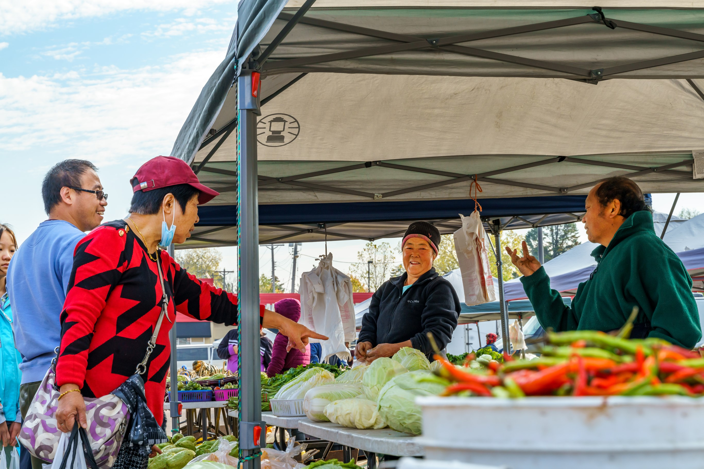


Regional vision
A prosperous, equitable, and resilient region
with abundant opportunities for all to
live, work, play, and thrive.

Regional core values

Equity | Leadership | Accountability | Stewardship

Regional goals

Our region is equitable and inclusive
Racial inequities and injustices experienced by historically marginalized communities have been eliminated; and all people feel welcome, included, and empowered.

Our communities are healthy and safe
All our region’s residents live healthy and rewarding lives with a sense of dignity and wellbeing.

Our region is dynamic and resilient
Our region meets the opportunities and challenges faced by our communities and economy including issues of choice, access, and affordability.

We lead on addressing climate change
We have mitigated greenhouse gas emissions and have adapted to ensure our communities and systems are resilient to climate impacts.

We protect and restore natural systems
We protect, integrate, and restore natural systems to protect habitat and ensure a high quality of life for the people of our region.


Overview
To ensure that the Met Council heard community advice and incorporated into Imagine 2050 policy, we focused engagement efforts on groups historically overlooked in regional planning efforts, such as young people, people of color, immigrants and American Indian communities. As part of this effort, Met Council staff convened a workshop series with community leaders in two phases. The first was in 2023, collaborating with five youth organizations in the Young Leaders Collaboration. In 2024, the Council collaborated with four groups focused on multi-generational immigrant and African American communities, the Community Leaders Collaboration. In this report, the two phases are referred to as the Community Leaders Collaboration. The purpose of this report is to summarize findings from Community Leaders Collaboration workshop and research processes around the land use issues communities face in the region.
Community leaders studied Met Council authorities, selected focus themes, conducted research on experiences of diverse youth (ages 14 to 24) and adults in the metro region. They presented results to Met Council members and staff. Participants designed research to learn the perspectives of young people or adults in their communities, interviewing more than 200 people in total. This report is organized to connect with existing transportation policy and identify the gaps in the current policy.
This report contains a comprehensive list of all themes mentioned by community leaders related to the report topic. Researchers and planners involved in the project reviewed all materials from the Community Leaders Collaboration workshops and presentations. A lead researcher used reflexive thematic analysis, considering policy area needs. The lead researcher then identified categorizing labels (codes) for ideas expressed by community leaders. These codes were then placed into themes (headers and subtopics presented in the report), which were then rigorously reviewed by the lead researcher and additional researchers or planners.
Community leaders participated from these organizations:
- 4H, Scott and Carver County
- Environmental Stewardship Institute, regionwide
- Esperanza United, Dakota County
- Raices Latinas, Hennepin County
- World Youth Connect, Ramsey County
- Mi Casa, Scott County
- Community Resource Center and Shakopee Diversity Alliance, Scott County
- COPAL, regionwide

Gaps in current regional goals: cultural landscape
Land use policy influences the cultural landscapes through directing the built environment to support the needs and desires of community members. In this case, cultural landscape refers to the ways space and land are modified over time into an environment that reflects culture, history, human necessities, and lifestyles of past, current, and future inhabitants. For community leaders, cultural landscapes set the stage for their access to community and cultural connection.
The community leaders defined community and cultural connection as the ability to engage with community members, the community infrastructure, and if they felt like the community reflected their cultures and identities. Community Leaders often evaluated their experiences living in the region against their ability to connect with their community and cultures. People also noted that less urbanized parts of the region are not providing the spaces, events, housing, and businesses needed to support the changing community and cultural connection within their communities. According to one community leader, “more policymakers [should] become more culturally aware on the needs of the community.” Below, Figure 1 identifies the pillars of community and cultural connections that community leaders have recommended to mitigate gaps in current policies as the region continues to rapidly diversify.

Figure 1: Pillars of community and cultural connection based on advice from community leaders.
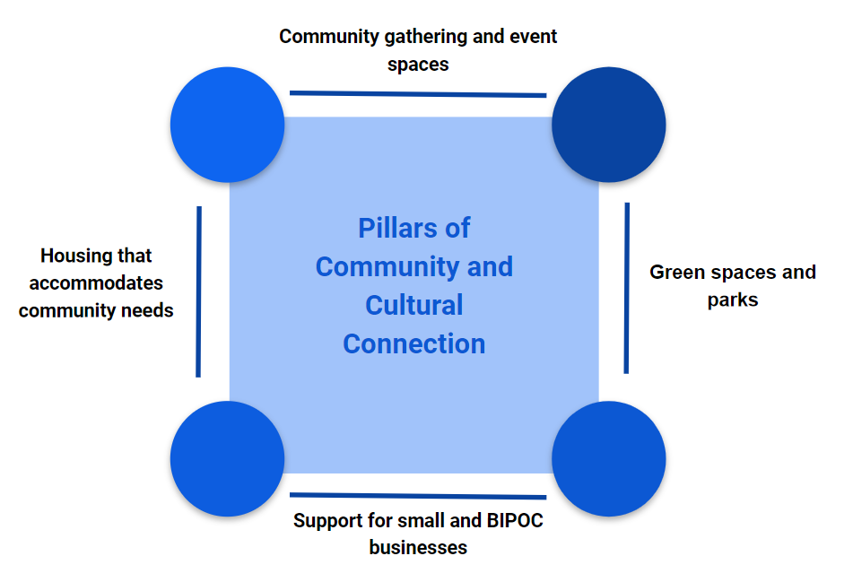

Community and cultural connection are important for residents’ health and prosperity

Dedicated open spaces and greenspaces for communities to gather and placemaking in open/public spaces to cultivate community connection.
Community and cultural connection are an essential part of residents’ identity and way of living. Community Leaders assert that as the region becomes more diverse, communities should begin to incorporate their cultures within the community fabric to feel “seen” and to cultivate connection through dedicated public/open spaces, greenspaces, and placemaking. Increased opportunities for community gatherings can support people in feeling safe in their community.
Currently, people feel a strong disconnect between themselves and the rest of the community as they have moved out into less racially and ethnically diverse areas of the region. Their culture, language, and traditions are not reflected within the cultural landscapes upheld by current land use policies and they do not feel like they are part of the community. The pandemic caused damage to residents’ cultural and social connections, requiring additional effort to support cultural landscapes through land use policy. To mitigate barriers of cultural and community connection, Community Leaders recommend the following:
- Dedicated open spaces for communities to connect through music and dance events, family gatherings, barbecues, and other pop-up events.
- Placemaking in open/public spaces to reflect community members’ need for cultural connection.
- Spaces for ongoing positive community interactions such as community gardens, community centers, and recreation.

Land use policy to support entrepreneurship and small businesses.
Community Leaders highlighted easily accessible culturally relevant businesses and resources as invaluable aspects of their communities. Locally owned and small businesses, and resources with cultural significance offer essential groceries, healthcare, and services that are scarce in other parts of the region. Due to various factors, people make tradeoffs that force them to move away from communities with culturally rich businesses and resources and into areas of the region with less development of cultural infrastructure. As the region continues to grow and diversify, a gap in culturally relevant business and resources will continue to grow if left unaddressed. As a result, people want to see more opportunities throughout the region for small local and culturally relevant businesses (informal and formal) to serve the community.

Supporting cultural norms, wealth-building opportunities, multifamily housing, and housing affordability through housing choice and multigenerational housing.
Young people living in urban and suburban areas of the region detailed their housing experiences highlighting multigenerational housing. For some young people, living with their parents, siblings, and grandparents/relatives is a cultural norm as it allows them to share housing and utility costs, household chores, and provide care for both younger and older relatives. Other young people attributed housing affordability as a key reason for living in a multigenerational home and sometimes found that the home was too crowded. When thinking about managing growth and development in the region, multifamily developments and dense residential development are encouraged to meet the needs of young people.

Community Leaders want to enjoy and benefit from investments in their communities.
Community Leaders expressed concerns over gentrification and displacement that comes with new investments. They have observed and experienced the adverse effects of gentrification wherein they and their families have been forced to move. Oftentimes, more affordable areas of the region lack cultural and social ties which may result in cultural displacement and strong feelings of disconnection from the new community and neighbors. As communities propose changes to bridge cultural gaps and build community connection, people want to be reassured that they will be able to reap the benefits of mindful investments in their communities.

Table 1: Community-described cultural and community connections in their lives
Topic | Examples from Community Leaders
Dedicated open spaces and green spaces for communities to gather and placemaking in open/public spaces to cultivate community connection | - “More community events, I can’t think of anything we do in our neighborhood.” (EU)  - ““I moved from Faribault, MN, where we had a community garden. I would like to see that in Shakopee.” (CRCSDA)  - “Add more gardens, garden centers, maybe…Enjoying plants, nature. Have more green grass so that everyone can enjoy the outdoors.” (Mi Casa)  - “There are times when people feel left out or feel out of place, and I would want my community to recognize all individuals and groups of people, which means putting in an effort to communicate and gather people together. To me that would show that every single individual’s insight and participation matters and means something. I would also add that representation would also be something I need in order to feel seen in my community.” (Raices Latinas)  - “Community to me means you feel comfortable. Not just safe, but you feel like you belong.” (WYC)  - “Young people feel seen when their culture is reflected and valued in their communities. Feeling seen and having a sense of belonging can improve outcomes for young people as it creates more culturally appropriate opportunities for wealth building and social connection.” (Raices Latinas)  - “There needs to be more cultural enrichment centers to help push younger generations to develop themselves and their communities.” (Raices Latinas)
Land use to support for entrepreneurship and small businesses | - Young leader from Raices Latinas expressed her gratitude for a Mexican grocery store in Bloomington. It was rare to see businesses specific to her culture, and that grocery store allowed her and her family easier access to culturally relevant food and groceries (see Figure 1 in Appendix).  - Talking about their life stories, young leaders expressed an interest in becoming small business owners. (Raices Latinas)  - “I started my own business to save money for college, balancing 18 credits along with work can be a bit draining especially when you don’t have a lot of time.” (WYC)  - “My parents are immigrants from Ethiopia. My mom owns a coffee shop. I drive to get supplies for the shop.”
Cultural norms, wealth-building opportunities, and housing affordability in multifamily housing | - “For housing, urban multi-family housing is really important. In the suburbs, you have single family homes, and you will want to live near parks or schools. It’s a good place for raising kids.” (EU)  - “If we are talking about families, Shakopee is becoming unaffordable. There is no public housing in Shakopee. The population is growing, and there is no increase in housing. In Minneapolis, affordable housing includes youth. In Shakopee, you will never see a unit dedicated to the youth. Minneapolis has public housing for the youth and the elderly. There are no options in this area.” (CRCSDA)  - “A lot of houses are being built but they are the same types of houses. But it doesn't help different types of families. The ones being built are single-family houses.” (Mi Casa)  - “We need the kinds of affordable housing that fit our families. Some of us want to live in multigenerational housing with parents and grandparents.” (WYC)  - “Youth are more likely to live with their parents because of the cost. Not everyone has a job or a career that’s enough for people to be able to afford rent themselves. Young people often stay with their parents for cultural reasons too. One of them may be helping out around the house whether it be physical labor or helping with rent.” (WYC)

Key concerns related to land use

Community leaders want more opportunities for connections to the natural world, parks, and trails.
Community Leaders expressed a strong interest in connecting to natural resources in the region. Community Leaders created the following recommendations:
- Our region’s communities have a park within walking distance for every person.
- Current and future open spaces are all connected to public transit, including regional parks, trails, and other recreational spaces across the region.
- Local parks and open spaces have many elements of nature in them and are places where people can connect with nature.
- Nature is not limited to parks and trails as connection to nature should be visible in every neighborhood.
- Every park and ride and transit center has natural habitat planted on site.
- Our region’s communities have abundant tree canopy, green space, natural habitat, and community gardens to support mental and physical health.
- Our region supports biodiversity in every neighborhood.
- Our region is a national leader for coexistence between human and nonhuman species.
Community leaders value water recreation and identify it as a unique feature of the region.
For community members, water recreation is a highly desirable aspect of living in the region but have noted disparities in access to water recreation across the region. People are in support of policies to regulate and monitor water quality and access.
Community leaders want to ensure efficient land use development that preserves and restores natural systems in the region: water, greenspaces, and farmland.
People living in communities with greenspace and farmland call for the protection against large developments to restore and preserve agricultural land and natural habitats. They have witnessed land being developed into large single-family homes and warehouses that severs their connections to nature and agricultural use. Community leaders described how housing development has caused harms to the biodiversity of the open space. As such, community leaders recognize that protecting natural habitats calls for dense and cluster developments. In the face of climate change, community leaders advise policies to carefully consider the impacts of their investments in regional infrastructure and prioritize habitat and natural systems restoration.
Safe pedestrian and bike-friendly neighborhoods create access for youth and nondrivers and healthier communities for all.
Young people in urban, suburban, and rural settings emphasized the importance of safe pedestrian and bicycle infrastructure. In less urban areas where transportation options are limited, young people and adults not driving are forced to walk across dangerous intersections and alongside cars where sidewalks are inadequate or nonexistent. In communities where sidewalks are not available, young people who rely on rolling cannot safely access their community in the same way as others. Aside from physical safety, having adequate pedestrian and bicycle infrastructure plays a positive role in mental and physical health for young people. Lastly, pedestrian and bike infrastructure are environmentally friendly alternative transportation options to school, work, and extracurricular activities for young people who do not drive. Because young people often can’t drive, they experience unique challenges in this area, but other nondrivers who roll or walk for transportation also are affected.
Community leaders desire walkable and pedestrian friendly communities with dense and mixed use commercial and residential development within urban and suburban communities.
As the region continues to grow, people would like to see more dense and mixed-use developments within urban and suburban communities. Due to inadequate transit networks in suburban communities, people would like to have places to walk to within their neighborhoods. Aside from public open and greenspaces, people would like to see more space for community amenities, retail, food, entertainment, etc.
Young people want communities to be planned around economic opportunities that reflect their current and future work lives.
Lack of transit access in suburbs and infrequent transit to economic opportunities such as work are key concerns for young people. Young leaders in many places in the region rely on transit to get to work and extracurricular activities after school. Other times they must rely on others to drive them to these activities due to lack of transit within their communities. Additionally, young people are often tasked with earning money to help support themselves and their families, which can result in working at multiple jobs. When young people do not have other transportation options they may miss out on these economic and educational opportunities. Young people want to improve transit access and frequency to economic and educational opportunities across the region.

Table 2: Key topics related to land use
Topics | Examples from Community Leaders
Opportunities for connections to the natural world, parks, and trails. | - "If there is public transportation like buses, it makes it much easier to get to parks, especially cause for a long time I didn't have a car." (ESI)  - “Every neighborhood should have access to green spaces to promote health and wellness and efficiency. Nature is huge in our culture.” (CRCSDA)  - Young leaders included parks within their community drawings often referring to them as spaces they value. (See Appendix Figure 2.)  - "Parks play a big role in my life because they provide an opportunity for me to get out to nature in my community, and exercise."  - “Parks give people access to nature, a sense of community, and activities they can do like walking, biking and playing sports. I don’t go that often because there’s not one close to the house. And I don’t want to go when it’s freezing cold.” (Raices Latinas)
Water is a valuable and unique feature of the region. | - “Water and noise pollution in parks should be prevented through land use policy.” (ESI)  - “Parks and water are fun to visit, and they’re free.” (4H)  - " I love to swim and every summer we go to Chisago, and every year the water seems to get darker and dirtier, I would like to learn how that happens and what can be done." (ESI)  - "Water for entertainment. We have so much water. Biggest impact besides keeping me alive gives me lots of things for my friends and I to do – skiing, snowboarding, paddleboarding, kayaking. Skiing and snowboarding are water dependent." (ESI)  - “People have cabins by lakes. A place for recreation, but not everyone can afford that. It’s something rich people want.” (4H)
Development prioritizes the efficiency of land use by preserving and restoring natural systems in the region: water, greenspaces, and farmland. current and future work lives. | - “It is especially important to consider the importance of green space in a growing community like Shakopee. With growth, there is pressure to build new homes or businesses on land that is currently open. A key issue for the area is balancing preserving and adding public green space with the demands of more development.” (CRCSDA)  - "I believe that people preserve land to keep natural wonders, instead of having it be taken by corporate buildings." (4-H)  - "In the future I would like to learn more about trees in our city, I think learning more about how we can protect our trees and what the overall forest ecosystem is." (ESI)  - "I think our city is lacking a lot of biodiversity, there's so much development and such little trees." (ESI)  - “For building you can put townhouses or fourplexes, instead of using more land.” (4H)
Safe pedestrian and bike-friendly neighborhoods create access for youth and nondrivers, and healthier communities for all. | - "I am more likely to go to a park that I have easy access to and especially if it's walkable." (WYC)  - “I tried to go walk to get ice cream with my sister. It was so hard to get there. We have to go down 13 on this hill, then we have to cross a busy highway. My sister is young. She has special needs and I need to keep her close, and it’s hard to do that when there’s not enough infrastructure for pedestrians.” (4-H)
Walkable and pedestrian-friendly communities with dense and mixed-use commercial and residential development within urban and suburban communities. | - “The Council can encourage more dense development, keeping housing and businesses in one area, makes areas more walkable, which we support.” (4-H)  - “Having a walkable city is good for basically everything it reduces the carbon footprint of the city. It increases the use of transportation. Having places that are walkable is good for the health of the citizens.” (4-H)
Communities planned for economic opportunities that reflect young people’s current and future work lives. | - "I don't have my license, there are times when I'll have to go to work and my mom can't drive me. Plus my job is 15 minutes away." (EU)  - “I also think that they (restaurant industry) take advantage of the age of young people, because they know we just want to work and they pay us less than we should be making.” (EU)  - “I think that as a young person, we want to be able to work in more areas.” (EU)  - Story session: Young leader from Richfield attends high school, works at a senior assisted living facility, cleans offices on the weekends, and works with mother at her mother’s money service business. She hopes to have her own small business one day like her mom. (Raices Latinas)

Policy implications

Implications for managing growth and development with displacement mitigation.
Community leaders expressed that due to the increasing cost of living, they must leave neighborhoods where they feel socially and culturally connected and move into areas in the region lacking these ties, resources, and access to transit. As government agencies and stakeholders address residents’ transit, transportation, and housing concerns, we urge staff to coordinate with other staff and stakeholders, and to evaluate the impacts of investments in the region to mitigate displacement. Doing so will ensure people who are intended to benefit from these investments and resources can access them in their communities.

Further resources
Community Leaders and Young Leaders presented their recommendations to the Metropolitan Council. Young Leaders’ Presentation at May 17, 2023 Committee of the Whole Meeting and Community Leaders’ Presentations in March 2024 Committee of the Whole Meeting can be viewed online. The presentations describing land use policy recommendations are:

2023 Young Leaders Collaboration
- 4H presentation (15:30)
- ESI presentation (48:40)
- Esperanza United presentation (1:07:20)
- Raices Latinas presentation (27:10)
- World Youth Connect presentation (1:23:00)

2024 Community Leaders Collaboration
- Community Resource Center & Shakopee Diversity Alliance presentation (31:48)

Please note that not all recommendations are attributed to specific organizations. If geographic distribution or identity is important to the application of this report, please contact us.

Report contacts

Darcie Vandegrift
Principal Researcher, Community Development
darcie.vandegrift@metc.state.mn.us

Gabriela Olvera
Planner, Community Development
gabriela.olvera@metc.state.mn.us

Sarah Gong
Researcher, Community Development
sarah.gong@metc.state.mn.us

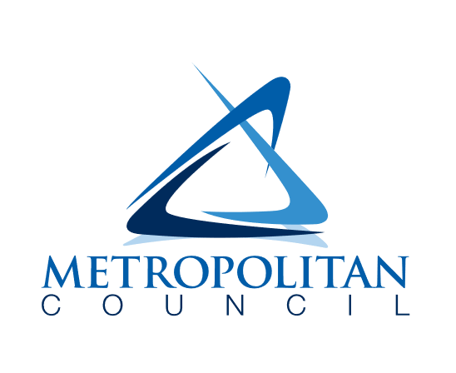

390 Robert Street North
Saint Paul, MN 55101-1805

651-602-1000
TTY 651-291-0904
public.info@metc.state.mn.us
metrocouncil.org/imagine2050



