housing policy recommendations
from community leaders
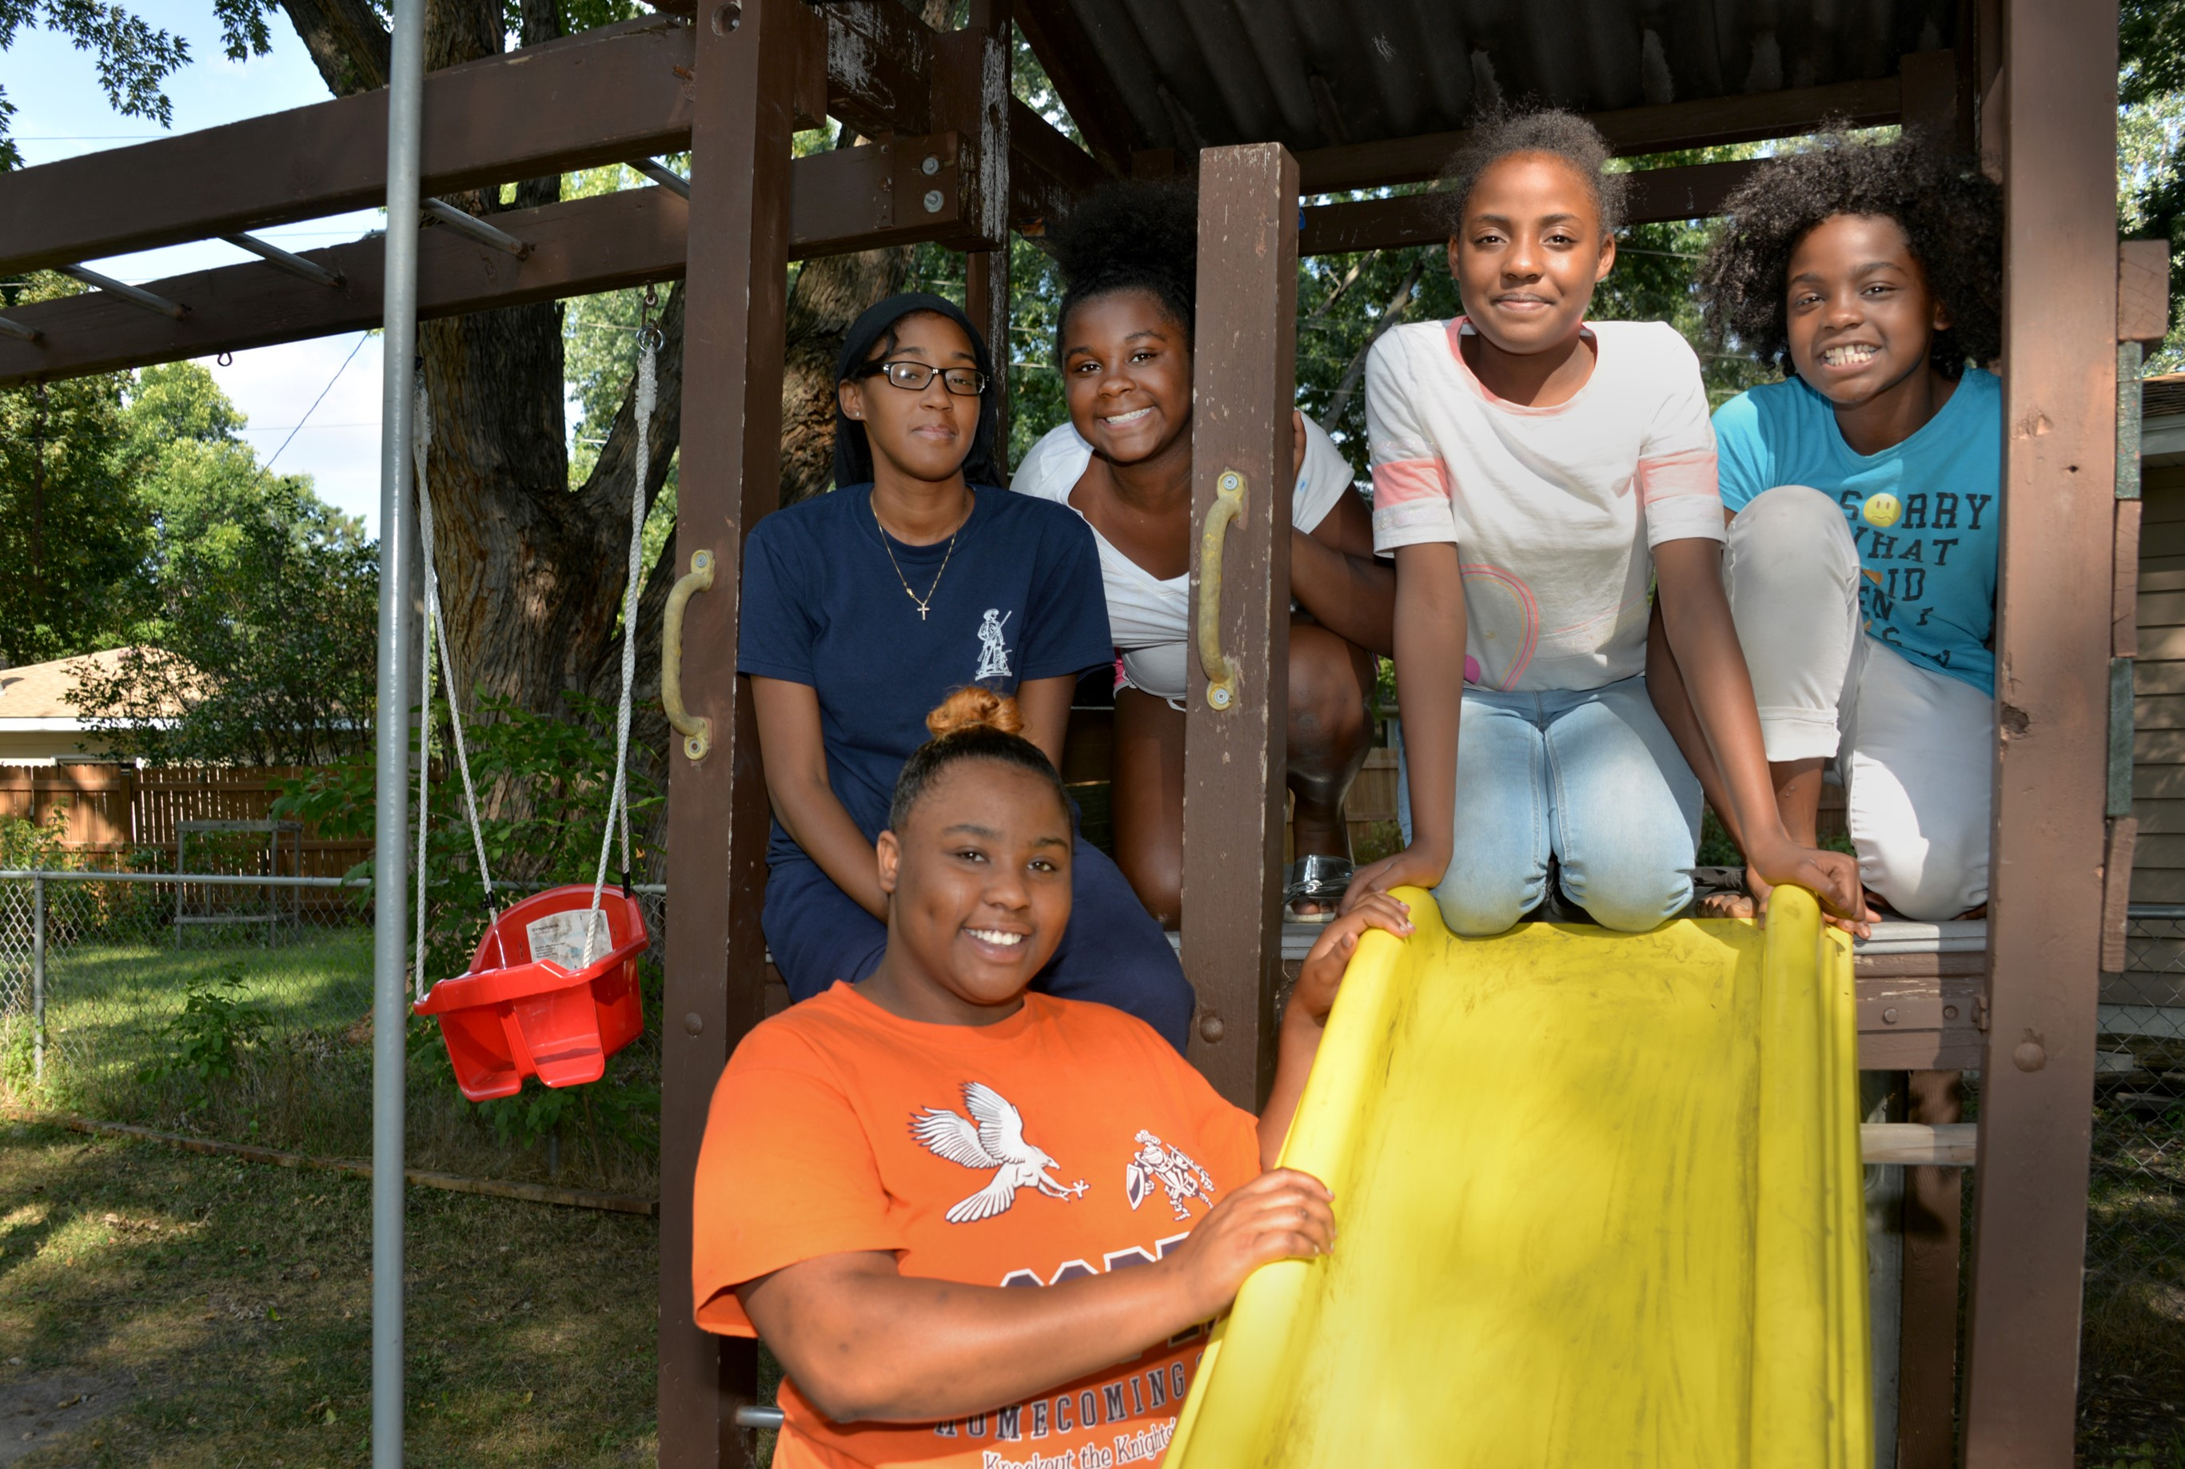


Regional vision
A prosperous, equitable, and resilient region
with abundant opportunities for all to
live, work, play, and thrive.

Regional core values

Equity | Leadership | Accountability | Stewardship

Regional goals

Our region is equitable and inclusive
Racial inequities and injustices experienced by historically marginalized communities have been eliminated; and all people feel welcome, included, and empowered.

Our communities are healthy and safe
All our region’s residents live healthy and rewarding lives with a sense of dignity and wellbeing.

Our region is dynamic and resilient
Our region meets the opportunities and challenges faced by our communities and economy including issues of choice, access, and affordability.

We lead on addressing climate change
We have mitigated greenhouse gas emissions and have adapted to ensure our communities and systems are resilient to climate impacts.

We protect and restore natural systems
We protect, integrate, and restore natural systems to protect habitat and ensure a high quality of life for the people of our region.


Overview
To ensure that the Met Council heard community advice and incorporated it into Imagine 2050 policy, we focused engagement efforts on groups historically overlooked in regional planning efforts, such as young people, people of color, immigrant and American Indian communities. As part of this effort, Met Council staff convened a workshop series with Community Leaders in two phases. The first was in 2023, collaborating with five youth organizations in the Young Leaders Collaboration. In 2024, the Met Council collaborated with four groups focused on multi-generational immigrant and African American communities, the Community Leaders Collaboration. In this report, the two phases are referred to as the Community Leaders Collaboration. The purpose of this report is to summarize findings from Community Leaders Collaboration workshop and research processes around the housing issues communities face in the region.
Community Leaders studied Met Council authorities, selected focus themes, conducted research on experiences of diverse youth (ages 14 to 24) and adults in the metro region. They presented results to Met Council members and staff. Participants designed research to learn the perspectives of young people or adults in their communities, interviewing more than 200 people in total. This report is organized to connect with existing housing policy and identify the gaps in the current policy.
This report contains a comprehensive list of all themes mentioned by Community Leaders related to the report topic. Researchers and planners involved in the project reviewed all materials from the Community Leaders Collaboration workshops and presentations. A lead researcher used reflexive thematic analysis, considering policy area needs. The lead researcher then identified categorizing labels (codes) for ideas expressed by Community Leaders. These codes were then placed into themes (headers and subtopics presented in the report), which were then rigorously reviewed by the lead researcher and additional researchers or planners.
Community Leaders participated from these organizations:
- 4H, Scott and Carver County
- Community Resource Center and Shakopee Diversity Alliance, Scott County
- COPAL, regionwide
- Environmental Stewardship Institute, regionwide
- Esperanza United, Dakota County
- Mi Casa, Scott County
- Raices Latinas, Hennepin County
- World Youth Connect, Ramsey County

Key community concerns related to housing and housing affordability

Housing affordability is a challenge across the region
Seven of the eight groups found significant problems with affordable housing among community interview participants. The research identified unique variables influencing housing affordability and variables affected by housing affordability, as demonstrated in Figure 1: Expanding understanding of housing affordability (page 14).

Findings specific to youth and young adults

Young people face barriers to housing accessibility.
Young people often lack knowledge of navigating renting for themselves for the first time. Additionally, young people are often dealing with education costs on top of housing and other cost-of-living expenses. Sometimes, some young people want to move out of their parents’ place but are unable due to unaffordable housing or affordable housing not located where they need to live (for example, near school or work). (At the same time, some young people would rather continue living with their families. See “emergent issues” section.)

Housing affordability has a significant impact on youth development, and thus the future of the region.
Lack of affordable housing impacts young people’s access to opportunities in education, recreation, and consumption. It also impacts the communities that young people have access to and are able to be a part of. All of these factors are impactful to a young person’s personal development.

Findings that were true of all ages

Where people live affects their access to resources and opportunities.
Jobs, social connections, the outdoors, and shopping were all important resources that people wanted to have close by. The tradeoff between good housing conditions and cherished communities was expressed by workshop participants. Community Leaders shared how their communities flourished when resources and opportunities were located in neighborhoods they could afford.

Contextual variables impact a household’s definition of housing affordability.
This includes wages, household size, educational expenses, and other cost-of-living expenses like food, utilities, and car expenses. Many of these costs vary geographically and vary significantly from household to household. This suggests the need for flexibility in terms of housing assistance, and that a “one-size-fits-all” definition of affordable housing is not sufficient.

Some people are forced to live in unsafe housing situations to improve housing affordability.
These unsafe conditions include living in old and deteriorating housing stock, living in neighborhoods with lots of crime, and large families living in housing that is not sufficient to accommodate their size.

Efficient land development is valued for the potential to preserve open space through higher housing density
In suburban edge, rural residential, and rural center areas where new land is converted to housing, conserving agricultural and open space through higher density housing will provide land for future needs.

Table 1: Key housing topics and examples from Community Leaders
Topic | Examples from Community Leaders
Young people face barriers to housing accessibility. | - “I’m staying with my family because it’s financially best for me. I’d rather move out, but I can’t because it's too expensive.” (EU workshop 3)  - “It’s hard to move out due to a lack of opportunity and money. Many people chose school which means they don’t have dedicated income for housing.” (Raices story session)  - “We are worried we won’t be able to find housing when we are adults.” (4H final presentation)
Housing affordability has a significant impact on youth development, and thus the future of the region. | - “Where you live is the education you receive. It is all tied together. I can say I come from a lower income area. The high school I was supposed to go to is not the best. It’s the revolving cycle. Youth who come from low-income families and don’t have the resources and programs don’t have the opportunities. It’s the cycle we go through.” (Raices Latinas)  - Some young people shared that stores and other third spaces in the places where they live are unaffordable, which is a barrier to consumption, recreation, and community connection. (Raices Latinas)
Where people live affects their access to resources and opportunities. | - “In Shakopee, the work here does not pay enough for housing here. A lot of people commute out of the city. My mom does, I do, my friends. The best paying jobs for entry level is like Amazon.” (Mi Casa)  - “Our current housing system does not provide equitable opportunities to all the region’s residents and needs to change to eliminate housing disparities across race and class.” (CRCSDA)  - “I want to get a better job, but the good jobs are all in places too far for me to travel. I can’t move there because I can’t afford it.” (COPAL)  - CRCSDA interview results found that people like Shakopee because it is quiet, safe, and close to their community. They want to stay in the area, but they feel pressure from the lack of affordable housing in the area that meets their needs.
Contextual variables impact a household’s definition of housing affordability. | - “Every year housing goes up; however, the pay rate doesn’t seem to go up. A 50-cent raise at work is not sufficient when your housing payment goes up 50 dollars.” (EU)  - “With wages, most people aren’t able to pay because their salaries aren’t high enough, so they’re working 2-3 jobs.” (Raices Latinas)  - One young leader’s family struggled to find affordable housing that could accommodate their family’s size. (Raices Latinas)
Some people are forced to live in unsafe housing situations to improve housing affordability. | - “Safety is unaffordable.” (WYC)  - Several young people shared that their families were forced to live in neighborhoods with crime and housing conditions that were unsanitary in order to find housing that was affordable.  - “As I lived in an apartment for nearly 9 years after I first came to the U.S., this place was unsafe in terms of the living condition and unsafe in terms of violence. I only lived there because it was more affordable for my family … There would be fights going on every day, people would break in. … Not only that, it was unsafe in terms of the living condition because there was mold, mice, rats, roaches—and we all know this has direct impact on our health.” (WYC)
Efficient land development is valued for the potential to preserve open space through higher housing density. | - “Cookie cutter houses and houses on large lots are not an efficient use of undeveloped land. Encouraging more dense development, keeping housing and businesses in one area, and making areas more walkable are desired goals.” (4H)
Immigrants have specific housing needs and affordability tradeoff considerations. | - “Immigrants and minorities are losing their heritage due to location. I’ve seen this personally. When I moved to the U.S., I lived in an apartment with other Karen people, bringing me closer to them. As we grew up, our needs changed and we had to move. We are farther from the Karen community now. This causes communities to drift away and kids to lose touch with their own culture. There is no safety or bonding.” (World Youth Connect)  - “I have a large family and I couldn’t find a single [home] that fits my family, which forced us to live in 2 separate homes.” (CRCSDA)  - “Immigrant families are getting phased out to outer suburbs.” (Raices Latinas)  - “Some young people want to live on their own, but sometimes we want to live with our families, across generations.” (WYC)

Emergent issues
Several important issues emerged throughout the engagement process that historically have been less considered in policy making. Centering these issues in conversation and policymaking is necessary to address the gaps in policies. Community outreach and engagement is important in the discovery of these emergent issues, allowing government agencies to better align our work with the needs of communities.

Housing affordability affects community belonging and community connection
When housing is unaffordable, people can’t choose to live where they want. Due to financial necessity, some families of color and immigrant families have to live in neighborhoods where they do not feel welcomed, do not feel connected to their culture, and/or do not feel connected to their community. As such, there is a need for policy to support cultural institutions (ethnic and immigrant-owned businesses, cultural centers, culturally competent services, etc.)

Immigrant families face barriers to housing accessibility
This can be due to immigration status—landlords sometimes discriminate based on immigration status. Renting sometimes requires having a social security number. Getting a mortgage also sometimes requires a social security number. It can also be due to lack of knowledge or wealth.

Multigenerational housing and housing for large families is important for many families in the region
In some cultures, living with multiple generations in a household is culturally important. Living with multiple generations in a household is also done to reduce housing costs. As such, there is a need to build affordable housing that accommodates large family units.

Table 2: Emergent issues in housing and examples from Community Leaders
Topic | Examples from Community Leaders
Housing affordability affects community belonging and community connection. | - “We have been wanting to move for the last few years but we want to stay in the Shakopee area because that is where our friends are/community is. But it is hard because housing prices are going up.” (Mi Casa)  - “A safe community is also where you belong. You know your neighbor, and everyone feels comfortable around each other. That feeling that every person around you has your back.” (WYC)  - “Our families, given the jobs they have to work, they are always in a place that is insecure to pay for housing. This affects how you can show up for your kids or your families.” (Raices Latinas)
Immigrant families face barriers to housing accessibility. | - “For my parents it was very hard, my mom moved here when she was 15 it was super hard growing up in America, there wasn’t established housing, it really shows the injustice that immigrants go through when looking for somewhere to live or somewhere to work.” (EU)  - The Met Council should explore ways to develop or increase access to culturally competent resources related to housing. CRCSDA interview participants discussed how language and cultural barriers made it harder for them to find housing and housing resources. This could include Sharia-compliant financing structures to support Muslim families hoping to buy homes.  - “I think that we need more consideration, for first timers, for immigrants—more education on housing affordability. People don’t know that a minimum downpayment will mean that it’s a higher monthly pay and vice versa. It was similar for my family—my parents didn’t know about the financial cost it took … There were lots of conflicts that would come up but they didn’t know how to navigate it.” (EU)  - “We need more education and opportunity for first-time home buyers. My mom bought her house for the first time. My mom suffered so much trying to buy a house, it took a lot of hard work for her to earn her house, which was a dream for her to buy a house. (EU)  - “Policy makers may be able to create an impact on educating people on how to buy a home. I don’t know how to buy a home. You don’t learn that type of stuff in school. We need to educate people how to prepare financially for how to buy a house.” (EU)  - “My white friends work as a hobby, to fill up their time, or just extra spending money. I work to help provide for my household. … Housing was cheap for my white friends. Even for people in the same social class, things are different. … My parents need to work twice as hard to make the same advances in their career field. Regional planners should consider immigrants. They don’t have that generational wealth.” (Raices Latinas)
Multigenerational housing and housing for large families is important for many families in the region. | - “I grew up with a lot of family members in my household. There’s me, my four siblings, my sibling’s kids, my grandparents; so there was always a lot of people at my house. So I feel like if I go to a different household, I would also enjoy that madness of having a bunch of people in it … just because that’s how I’m used to.” (Raices)  - “Two of my friends’ families are like 13 or 14 people. They had a really hard time finding houses. I feel like they looked at 2 different houses. It is really hard with a big household.” (CRCSDA)  - “I lived in a one-bedroom house with 8 people, it was hard for my sister and I because we were going back and forth in houses—because my parents couldn’t understand nor afford living here. (EU)  - “Let’s say a lot of people come to the U.S. at once; most won’t have a job at first and will have to live in a small house with only one or two bedrooms. This is a challenge for immigrants in finding houses.” (EU)

Recommendations
This section details Community Leader perspectives on issues and questions identified as important by housing planners in the Met Council’s Community Development division. For each issue, several visions and goals that the young leaders developed are listed, giving insight into the changes Community Leaders would like to see in their communities and across the region.

What does ‘affordability’ mean?
Affordability is not something that has a simple definition. Community Leaders described diverse meanings and definitions of the concept. Going forward, policies can better serve the region through recognition of the need for flexibility. They created more precise definitions about how much people should be paying for housing and what other costs and factors should be considered when determining affordability. They sometimes held broader definitions, noting that affordability doesn’t just mean that a family can find a housing situation they can afford financially, but that they can afford housing in neighborhoods they want to live in, in housing conditions that are safe, and that meet the needs of their family in terms of culture, community connection, and family size.

What is a desirable neighborhood?
In their neighborhood, people want to feel a sense of belonging, and feel a sense of connectedness to their community(ies). They desired more third spaces for community members to gather and hold events or engage in creative activities. Young people referred to this as “being seen.” Research on youth development have noted that this sense of belonging is particularly important in adolescence when key identify formation is taking place. A Latino youth group noted: “To feel seen, being able to go to places where we see people who look like us and hear people speaking Spanish is important.” [Raices Latinas]

What is ‘home’?
Community Leaders described desired characteristics of home to a lesser extent than a desirable neighborhood. Some issues mentioned included having a home that was the right size for their family, a home connected to cultural meaning, and a home that allows for family connection.

What choices do families/community members make about housing?
Community Leaders noted several tradeoffs that they or people in their community navigate when making decisions around housing. These include: the tradeoff between affordability and living in a community where people feel represented, connected with the rest of their community, and feel a sense of belonging; the tradeoff between affordability and safety from crime and living in healthy and safe housing conditions.

Table 3: Recommendations for housing and examples from Community Leaders
Topic | Community Perspectives and Recommendations
What does ‘affordability’ mean? | Quotes:  - “It depends on how much you make, and how much other things cost. I believe that you should be able to put fifty percent into savings… 5 to 20 percent should go to food and other things.” [EU]  - “Affordable housing means making housing more reasonably priced and accessible in the neighborhoods we want to live in.” [Raices Latinas]  - “I grew up in section 8 housing. We were lucky to be a part of that type of housing to find affordable housing for my parent’s income. … Honestly, it is becoming increasingly harder to be in welfare programs, and to be in section 8, and everything in that boat … A lot of families are not qualifying even though they really need it. … I think we need to be more flexible, rather than just looking at the numbers, especially if you have more kids, especially if you are in school.” [EU]  - “Big companies are buying houses and flipping them. People are used to owning own home and values of community. Companies buy them and flip them and it becomes a super expensive place. This impacts the amount of young people who are impacted by amount of access to home ownership based on not being able to do it and having to keep renting for years.” [Raices Latinas]  Recommendations (Visions/Goals)  - Larger families have access to housing that accommodates their size.  - The region’s residents have affordable housing close to the cultural connections they need.  - Children live in affordable housing and supportive communities so they can have a stronger focus on school and education.  - The region supports people who cannot afford their housing and provides resources to ensure they can pay for housing.  - Affordable housing options are available for all members of the community. Everyone has access to safe and affordable housing options, regardless of their income level.  - The region provides affordable housing for students who will be attending college away from home.  - The region addresses housing affordability issues by increasing the wages and decreasing housing cost.  - The region builds more multi-family housing at lower costs for young adults.  - Affordable housing policymaking takes into account the cost of utilities, housing maintenance costs, other costs of living, education costs, etc.  - Our region creates more affordable housing options across diverse types of housing across the region.
What is ‘home’? | Quotes:  - “Recently we had a house fire, and we had to expand and make our house our own way. The way my parents are doing it right now is very Hispanic-oriented. There would be a lot of colors and designs that come from Mexico. When I’m looking for houses, I want that homey feeling of where I’m from and where I originated.” (Raices interviews)  - “I grew up with a lot of family members in my household. There’s me, my four siblings, my siblings’ kids, my grandparents; so there was always a lot of people at my house. So I feel like if I go to a different household, I would also enjoy that madness of having a bunch of people in it … just because that’s how I’m used to” (Raices interviews)  Recommendation:  - Larger families have access to housing that accommodates their size.
What is a desirable neighborhood? | Quotes  - “In order to feel seen in my community, to me it is important to feel like I belong and like I am a part of the community. I need physical and emotional safety, which allows me to be my authentic self. … I live in a place where it is not too difficult to meet and engage with people I share interest, passion, and life experiences with. However, if I lived in a more isolated area, for example, fostering a sense of belonging would be much more difficult.” [Raices packet]  - “[To be seen in my community, I would need] more citywide events where people of all different backgrounds come together.  - “There’s this park, … when I was growing up it was super white, only white kids played there. As they changed it, more schools, and I see more Hispanics and stuff like that. They’re more welcome and they do soccer stuff there for the kids. I feel like it’s better, not just for me as an individual, but for the kids growing up, … they can go there and see people who look like them.”  - " I would like my neighborhood to be more safe, no more shootings, or violence" (WYC interview)  Recommendations (Visions / Goals)  - Cities and regional systems provide a sense of respect for diverse communities.  - Create public spaces, green/open spaces, and increase placemaking strategies dedicated to cultural representation.  - Increased mixed-use development centers across suburban neighborhoods.  - The region’s residents have affordable housing close to the cultural connections they need.  - The region provides opportunities and resources in the neighborhoods where people already live.  Insights from hand-drawn maps  - Housing with friendly neighbors  - Healthy food (“not just gas stations”) within walking distance  - Restaurants nearby  - A library nearby “to pick out books and movies, have more space, and study groups.” For example, all of Raices Latinas youth put the library on their map.  - A Target to spend time with friends and get coffee (the Target was mentioned as a desirable place to hang out by more than one group).  - Important locations: Work, school, recreation, parks, lakes, trails, family, friends, hospital, churches, parking, transit centers, and grocery stores.  - Third spaces included Mall of America, Midtown Global Market  - Some youth would write their previous homes and apartments on the map. One youth wrote on her old apartment building “RIP” because it had been torn down.
What choices do families/community members make about housing? | Quotes  - “My family decided it would be better to stay where we are during college because of cost. We are looking to move out soon, but Richfield area is too expensive. More likely we will be in Minneapolis.”  - “I love Minneapolis. I liked Richfield when I lived in that area. It’s really expensive to the point that a young adult before could get a little quadruplex in Uptown, and now, not even that is available. in Richfield, lots of families are getting phased out. The apartments built are too expensive, these complexes are not affordable. More likely that people my age are ending up moving to North Minneapolis. That’s creating gentrification for communities there.”  - " I live with my mom because she lives closer to my job and school, purely off transportation convenience."  - “I used to live with my aunt’s family her 2 kids and husband we couldn’t afford our own place so we had to live together for many years.”  - "I where I live because it's affordable for me, I can't live in a safe neighborhood because it's expensive."  - "If money weren't an issue I would live in safer community, but since we can't afford to pay our rent and buy a good house we have to be in a cheaper and unsafe house."  - "If money wasn't an issue I would want a bigger house, and bigger space between my neighbors because it feels very crowded."  Recommendations  See previous recommendations related to community connection, public spaces, and safe neighborhoods.

Understanding population-wide and youth-specific variables influencing and affected by housing affordability
Community Leaders across the region analyzed the factors that influence affordability for individual households. They also identified factors that are influenced by affordability. Planners can review policies for each of the factors independently. Some identified variables are experienced across the life span. What is the comprehensive plan's effect on cultural connection? On community safety? How are policies considering the effects of family composition, household expenses, and income generation? Other variables are youth specific. How does housing affordability affect youth development opportunities? These variables can be addressed both independently from and connected with housing affordability itself.

Figure 1: Expanding understanding of housing affordability: Findings from Community Leaders' analysis, 2023-2024

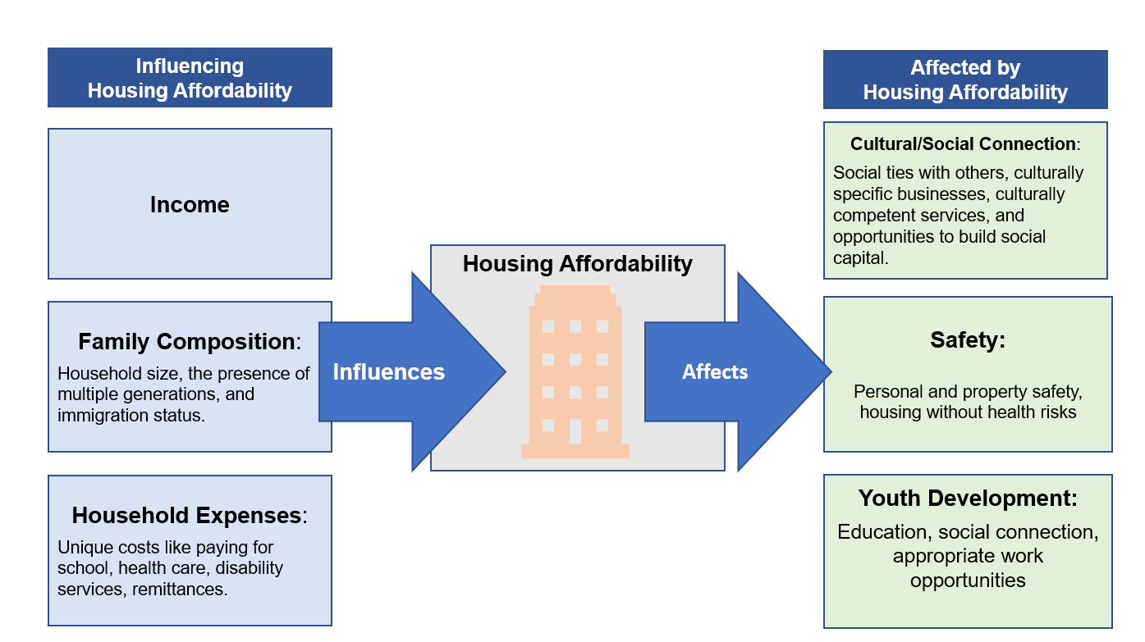

Note: Youth development includes resources to spend on youth activities, freeing young people from long work hours, access to high-quality schools, ability to attend social, sports, and art gatherings, ability to connect and have fun. These are important in young people’s current lives and also for future community and economic contributions.

Implications for metrics to measure success of regional policies
These variables identify potential metrics to evaluate success of policies through focus groups or survey data.

Community connections
- Do residents of communities with investments feel more community connection? Do they feel safer?
- Do young people in areas with higher investments have opportunities to participate in activities that support youth development?
- How many public spaces are available for cultural connection compared with 10 years ago (by jurisdiction, census tract, regional park agency)
- Are the number of immigrant-owned businesses expanding or contracting in a community?

Affordability
- What is the distance/travel time to affordable groceries/child care/other necessities for specific neighborhoods?
- How many jobs do adults in the household have (or how many hours do adults in the household work per week)?
- How do trends in local housing costs compare to trends in local wages?

Access to desirable housing options
- Is the rate of multigenerational household, single household homeownership expanding or contracting?
- How many comprehensive plans by community designation consider the need for small, culturally specific businesses, safe and affordable housing, multigenerational housing, housing for young people post-high school?
- Replicate the Young Leader’s Collaboration. Do we observe more feelings of belonging, being seen, safety, and access to desirable affordable housing options?

Youth development
- How many comprehensive plans consider the needs and well-being of residents ages 14 to 24?
- Retention of young people in the region

Consider topics:
- How the region’s housing policies and programs can support educational needs for renters and homeowners who are young people, immigrant communities, Black, Brown and American Indian communities, and other underserved communities.
- The impact of immigration status on livable communities and accessing affordable housing.
- The importance of multigenerational housing for families in the region and how planning can accommodate for this.
- The influence of housing and land use on community connectivity and cultural belonging and how our region can plan for interconnected communities.
- How housing and land use can convene conversations about emergent issues (for example, how can cultural preservation be a land use issue?).

Further resources
Community Leaders and Young Leaders presented their recommendations to the Metropolitan Council. Young Leaders’ Presentation at May 17, 2023 Committee of the Whole Meeting and Community Leaders’ Presentations in March 2024 Committee of the Whole Meeting can be viewed online. The presentations describing housing policy recommendations are:

2023 Young Leaders Collaboration
- 4H presentation (15:30)
- Raices Latinas presentation (27:10)
- Esperanza United presentation (1:07:20)
- World Youth Connect presentation (1:23:00)

2024 Community Leaders Collaboration
- Mi Casa presentation (15:25)
- Community Resource Center & Shakopee Diversity Alliance presentation (31:48)
- COPAL presentation (53:01)

Please note that not all recommendations are attributed to specific organizations. If geographic distribution or identity is important to the application of this report, please contact us.

Report Contacts

Darcie Vandegrift
Principal Researcher, Community Development
darcie.vandegrift@metc.state.mn.us

Sarah Gong
Researcher, Community Development
sarah.gong@metc.state.mn.us

Nicholai Jost-Epp
Intern, Community Development

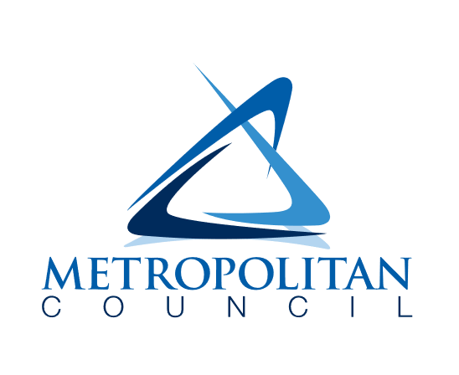

390 Robert Street North
Saint Paul, MN 55101-1805

651-602-1000
TTY 651-291-0904
public.info@metc.state.mn.us
metrocouncil.org/imagine2050



