Rural and Agricultural Engagements Summary for imagine 2050


Published October 2024

The Council’s mission is to foster
efficient and economic growth for
a prosperous metropolitan region

Metropolitan Council Members
Charlie Zelle Chair
Judy Johnson District 1
Reva Chamblis District 2
Tyronne Carter District 3
Deb Barber District 4
John Pacheco Jr. District 5
Robert Lilligren District 6
Yassin Osman District 7
Anjuli Cameron District 8
Diego Morales District 9
Peter Lindstrom District 10
Gail Cederberg District 11
Susan Vento District 12
Chai Lee District 13
Toni Carter District 14
Tenzin Dolkar District 15
Wendy Wulff District 16

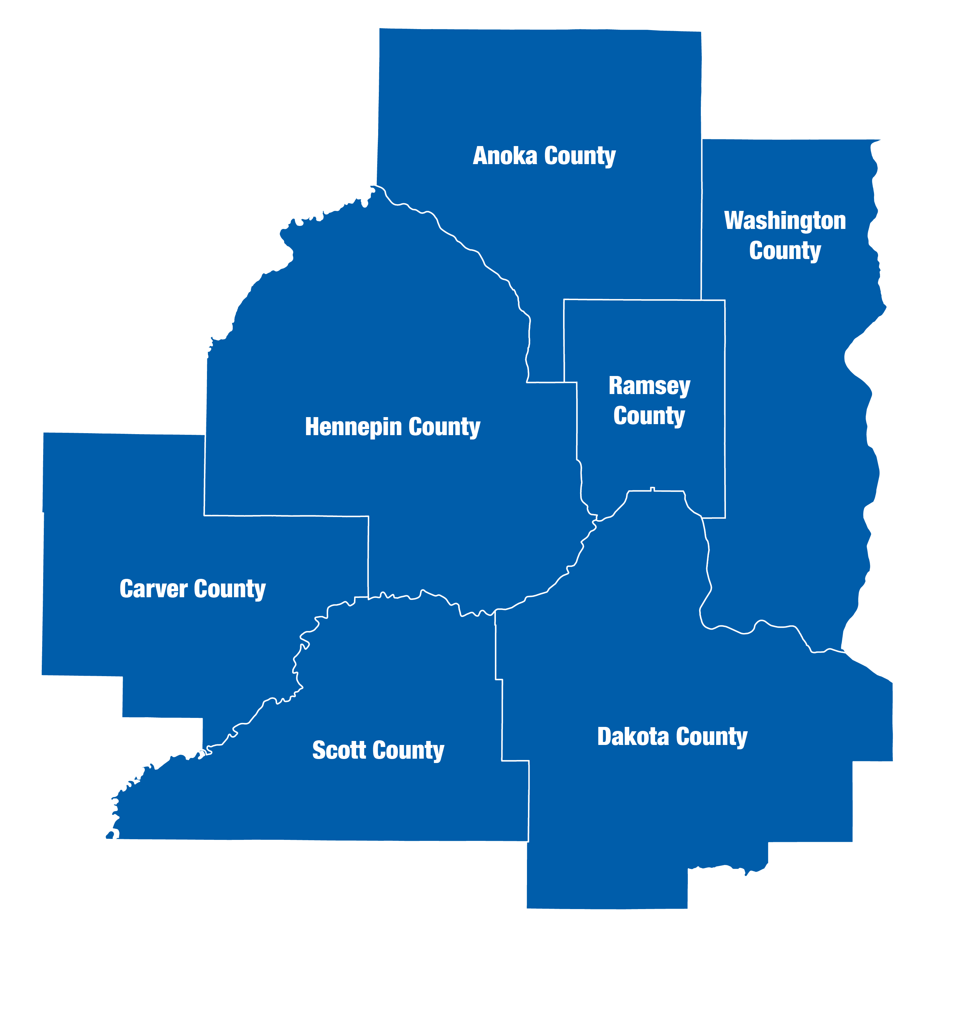
The Metropolitan Council is the regional planning organization
for the seven-county Twin Cities area. The Council operates the regional bus and rail system, collects and treats wastewater, coordinates regional water resources, plans and helps fund regional parks, and administers federal funds that provide housing opportunities for low- and moderate-income individuals and families. The 17-member Council board is appointed by and serves at the pleasure of the governor.
On request, this publication will be made available in alternative formats to people with disabilities. Call metropolitan council information at 651-602-1140 or tty 651-291-0904.

Rural and Agricultural Policy Engagements

Background
The seven-county metropolitan area covers nearly 2,000,000 acres, and nearly half of those acres are in jurisdictions with rural community designations (i.e. areas designated as Rural Center, Rural Residential, Diversified Rual, and Agricultural in Thrive MSP 2040). Looking toward the future, these areas are expected to constitute about seven percent of the region’s population growth and around four percent of the region’s new jobs between 2020 and 2050. The fact that this large geographic area accounts for a relatively small share of the region’s forecasted growth reflects the Metropolitan Council’s long-standing commitment to preventing premature development and promoting orderly and efficient development.
These rural and agricultural cities and townships are home to just over seven percent of the region’s population. These areas tend to be less diverse with approximately 88 percent of residents identifying as White in the 2020 Census compared to the 70 percent of residents regionwide who identify as White. Residents identifying as Black, Asian, and Latinx are particularly underrepresented in the rural portions of the region (1 percent versus 10 percent, 2.3 percent versus 7.8 percent, and 3.45 percent versus 6.7 percent, respectively). The rural areas tend to have a higher rate of home ownership than the rest of the region (90 percent compared to 67 percent), as well as larger average household sizes (2.79 as opposed to 2.5 people per household).
These Rural Areas, despite their relatively small share of the region’s population, play a significant role in the regional economy. The seven-county metropolitan area is home to over 3,700 farms and the majority of those farms are in the region’s rural areas. Together they produce products with over 600 million dollars in market value. The industries that have grown up around agriculture also play a significant role in the regional economy. These industries vary in scale from local hardware stores to Cargill, the country’s largest privately owned company.
The Metropolitan Council has always acknowledged the importance of rural communities and food producers to the vitality of the region; however, feedback received after the adoption of Thrive MSP 2040 led Metropolitan Council staff to conclude that more needed to be done during the Imagine 2050 planning cycle to engage with rural communities. As part of an increased emphasis on stakeholder engagement throughout the process of drafting Imagine 2050, the engagement plan focusing on soliciting input from the rural areas of the region and food producers, both large and small scale was developed and implemented. Council staff partnered with the Minnesota Department of Agriculture to better reach and connect with food producers and organizations involved with agriculture and used its existing connections to reach out to jurisdictions with rural community designations under Thrive MSP 2040. The scope and results of the engagement plan between its initiation in August of 2023 and the start of the public comment period in August of 2024 are detailed in this report, along with relevant activities that occurred as part of other outreach efforts.

Engagement Activities
Every city, county, and township with either a Rural Center, Rural Residential, Diversified Rural, or Agricultural community designation under Thrive MSP 2040 was invited to attend an in-person listening session. Two listening sessions were offered, one in the southwest metro and one in the northeast metro. Every local government that was unable to attend the listening session was subsequently invited to respond to a survey. Of the 91 jurisdictions invited to participate 31 either attended a listening session or responded to the survey. This resulted in 3 counties, 14 cities, and 14 townships providing input.
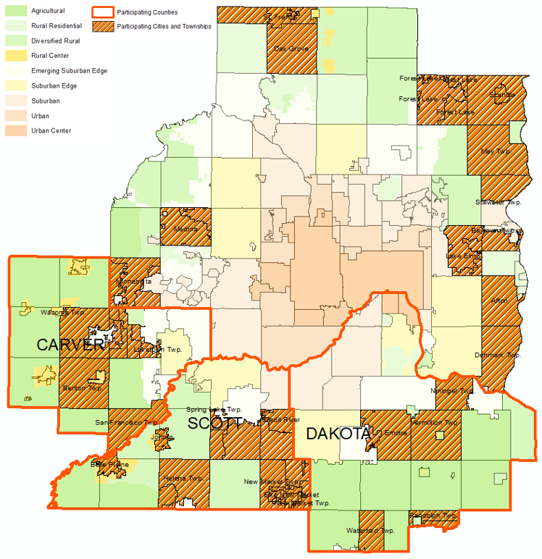
Similarly, staff used a combination of in-person listening sessions, surveys, and meetings with organizations that represented or worked extensively with food producers to provide residents not affiliated with local or county governments an opportunity to contribute to the formation of the Metropolitan Council’s rural and agricultural policies. As a result of these efforts, 17 people attended listening sessions, 51 food producers responded to the survey, and six meetings with individual organizations were held. It should also be noted that 9 of the 17 people who attended the listening sessions represented organizations affiliated with agriculture.
Finally, to learn more about food production and build relationships with individuals and organizations working in that realm, staff attended two conferences and a University of Minnesota Research Event. During these events, staff talked with other attendees about their concerns and ideas and promoted attendance and participation in the Metropolitan Council’s engagement activities.

Listening Sessions
Staff conducted four in-person listening sessions:
- Southwest Metro Listening Session
- 44 Jurisdictions invited
- Eight Jurisdictions attended (three counties, three cities, two townships)
- Northeast Metro Listening Session
- 43 Jurisdictions invited
- Eight Jurisdictions attended (five cities, three townships)
- Large Food Producers Listening Session
- Eight attendees
- Four of the eight attendees represented organizations
- Small Food Producers Listening Session
- Nine attendees
- Five of the nine attendees represented organizations

Surveys
Staff conducted four surveys:
- Southwest Follow-up Survey
- Four of eight attendees responded
- Northeast Follow-up Survey
- Four of eight attendees responded
- Survey of Jurisdictions with Rural Designations
- 75 jurisdictions invited to participate
- 15 jurisdictions responded (six cities, nine townships)
- Survey of Metropolitan Area Food Producers
- Survey widely distributed through partner organizations
- 51 food producers responded

Meetings
Staff met individually or in small groups with representatives of the following organizations:
- Midwest Farmers of Color Collaborative
- African Growers and Producers Alliance
- Somali American Farmers Association
- Minnesota Department of Agriculture
- United States Department of Agriculture
- Renewing the Countryside

Conferences/Events
Staff attended the following events where they were able to speak with food producers, solicit input, and raise awareness of Imagine 2050:
- University of Minnesota Urban Agriculture Student Research Event
- Minnesota Farm Bureau Urban Agriculture Conference
- 2023 Upper Midwest Farmland Summit

Young Leader’s Collaboration
In 2023, the Young Leader’s Collaboration worked with Scotty County 4-H to engage rural youth on issues relating to rural land use policy and agriculture. These 4-H club members interviewed 33 youths aged 14-18 throughout Scott County on questions relating to housing, open space, and pedestrian safety. They presented their findings to the Committee of the Whole on May 17, 2023, and their insights are incorporated into the Core Themes listed later in this report.

Distribution of Respondents
Metropolitan Council staff attempted to ensure that responses were received from every Met Council district that had jurisdictions designated as a Rural Center, Rural Residential, Diversified Rural, or Agricultural community in Thrive MSP 2040. The effort was largely successful with cities, counties, or townships from every district with one of these community designations responding except for District 10. District 10 has one community with a rural designation which did not participate in the engagement.
Regarding food producers, staff only collected county level data and cannot assess the distribution of respondents at the Council District level; however, residents representing each of the region’s seven counties either responded to the survey or attended a listening session.

Metropolitan Council Districts
The following table shows the number of cities, townships, and counties that provide input either in-person or by survey for each Metropolitan Council District containing communities with rural designations. The distribution of jurisdictions participating between districts roughly corresponds to the distribution of these community designations within the region
District 1: 1 | District 9: 2 | District 12: 5
District 3: 1 | District 10: 0 | District 15: 1
District 4: 13 | District 11: 7 | District 16: 3

Note: The total number of jurisdictions in the table is higher than the 31 distinct entities that attended because counties are counted under each district within their boundaries.

Counties
All counties with jurisdictions designated as Rural Center, Rural Residential, Diversified Rural, or Agricultural in Thrive MSP 2040 were represented, except for Ramsey County whose sole rural jurisdiction did not provide input. The distribution of jurisdictions participating between counties corresponds to the distribution of these community designations within the region.
Anoka: 2 | Carver: 5 | Dakota: 6
Hennepin: 2 | Scott: 8 | Washington: 8

When looking at the distribution of food producer listening session attendees and survey participants, input was received from all counties. Hennepin, Anoka, and Ramsey County are well represented; however, the more rural counties, especially Scott County, appear to be underrepresented. Several respondents/attendees chose not to list their county of residence, so an accurate distribution analysis is not possible.
Anoka: 7 | Carver: 6 | Dakota: 11 | Hennepin: 14
Ramsey: 10 | Scott: 3 | Washington: 9 | Unknown: 7

Core Themes
Listening session notes, meeting notes, and survey responses were reviewed and consolidated into unifying themes. These themes, as well as some specific policy suggestions, were used to help guide the rural land use and agricultural policy that was proposed in the Imagine 2050 draft released for comment in August 2024. Many different entities are active in these policy areas and at times staff received comments that would be mutually exclusive to implement. The themes listed below represent the input received during the engagement activities but may not necessarily reflect the policy position of the Metropolitan Council.

Jurisdictions
The condensed input from jurisdictions is provided below. Comments from a particular sub-group (i.e. township or communities in a particular geographic area) are indicated, when applicable.

Land Use:
- Region needs to prevent premature development and recognize that access to sewer is strongly linked to development pressure.
- There is tension between preserving open space, agricultural preservation, and developments. It can be challenging to identify what a piece of land is best suited for.
- Significant concerns over the loss of agricultural lands to solar developments.
- Universal frustration with annexation process.
  - Some feel the need for orderly annexation agreements can inhibit good planning. (Cities)
  - Some feel the annexation process unfairly favors cities. (Townships)
- 1 unit per 40-acre density limit on agricultural land:
  - Some feet it is vital to preserving farmland and allowing for orderly development (Southwest Communities)
  - Some are interested in smaller 5-10 acre farms/estates (Northeast Communities)
- It is challenging to balance development opportunities and farmland preservation.
- Inter-jurisdictional collaboration is key to good preservation and development outcomes.
- Development patterns:
  - Dislike patterns that are too rural for urban services but not rural enough for agriculture. The examples provided were 1 unit per 5 acres and un-clustered 1 unit per 10 acres developments (Southwest Communities)
  - Would like additional options for rural development pattern (denser than 4 units per 40 acres) without needing to be annexed into a city. (Townships)
- Desire to maintain rural lifestyle.
- Sentiment that the Metropolitan Council pushes density where it is not wanted and prevents density where it is wanted (i.e. requires 3+ units per acre in MUSA and prevents 2.5-acre rural estate style lots).
- There are tensions between urban nuisance ordinances and farming operations.

Agricultural Preservation:
- Agricultural Preserves Program: The 8-year period is a barrier and tax savings are often not worth it.
- Green Acres Program: The 3-year period is more appealing, but the structure doesn’t match how farmland is inherited.
- Conservation Easements: Situationally useful, but limited funding.
- Clustering development:
  - Not an effective way to preserve agricultural lands. (Southwest Communities)
  - Used to limit development (Northeast Communities)
- Success using homesteads to facilitate lease/sale of productive lands.
- There are too many programs with too complicated of processes to access.
- Hard for preservation to compete with developer cash.
- Often cities don’t find out a farm is considering ceasing operations until after it is sold to developer.

Policy Suggestions:
- Permit productive uses in preserved open spaces.
- Guide solar installations out of prime farmland and onto urban rooftops.
- Allow additional preservation of land without creating density issues.
- Advocate for cities to be able to further prevent/control development near borders. (Cities)
- Allow for higher density developments on septic/well (Townships)
- Allow townships to prevent annexations (Townships)

General:
- Concern over lack of resources (both staff and financial).
- Low staff capacity makes comprehensive plan amendments a major burden, smaller communities feel locked into the 10-year planning cycle.
- Everyone needs education on what options are possible.
- Cities need additional technical assistance to facilitate the preservation of farmland.
- Concerns over water supply/water quality

Food Producers
The condensed input from food producers is provided below. Both large scale conventional agricultural producers and smaller scale urban producers participated in the engagement activities. Many concerns are universal; however, some reflect the unique needs of large- or small-scale producers.

Land Access:
- It is very challenging for new farmers to acquire land.
  - Scale required for rural agriculture makes it hard for anyone to enter the industry.
  - High cost of urban land/difficulty identifying available vacant land makes it hard for urban farmers to get started.
  - Cost of land and market conditions make it hard to show income which makes it hard to get financing. Need access to local markets and long-term control of land.
- There is marginal/vacant/underutilized land that could be converted to productive land, and better mechanisms are needed to help match farmers with available land.
- Local ordinances unnecessarily prevent farming in urban areas.
- Need to create smaller (sub-10 acre) farmsteads without opening the door for residential development.
- Most programs only benefit folks who already own land, few beginning farmers start out owning land unless through inheritance.

Understanding of Farming
- Agriculture is not valued in land use decisions and decision makers, especially those from urban areas, are making policy for agriculture without understanding it.
  - The value of agriculture goes beyond tax base.
  - Highest and best use is not always the most profitable.
- Agriculture is changing, but policy/rules are slow to catch up.
  - Indoor agriculture is not adequately covered by the existing regulatory framework.
  - Movement away from monoculture.
  - Use of agrotourism, direct to consumer, etc.
- Nuisance laws created to protect residential areas from the impact of industrial agriculture are not necessarily applicable to small urban farms.
- Agriculture should be seen as an amenity, not a nuisance.
- Policies and programs revolved around either 40+ or 10+ acre farms; however, there are many smaller farmers active in the metro area. Policy should focus on producing food rather than industrial agriculture.
- Agriculture plays an important role in local economies (urban and rural).
- Agriculture plays an important role in responding to climate change.
- Many groups are interested in cooperative/communal farming models not permitted by current policy.

Agricultural Preservation:
- Often an economic decision. Incentives/tax credits are less than what can be gained by selling.
- Difficulties connecting farmers looking to exit with farmers looking to enter.
- Need to recognize that there is farmland in urban areas that also needs to be preserved.
- There is heavy development pressure on agricultural lands.
- Agricultural zoning should not allow non-agricultural uses (i.e. golf).
- Tension between the need to make enough on sale to retire and a desire to keep land in production.

Policy Suggestions:
- Expand Metropolitan Agricultural Preservation program to smaller parcels or create other programs to protect small acreage farms, especially in urban settings.
- Provide higher tier of credit in preservation programs for sustainable agricultural practices.
- Let agricultural lands count as preserved open space and identify areas within cities to be preserved for permanent agricultural uses.
- Allow for housing on agricultural lands (tiny houses, ADUs, agricultural condominium models, agrihoods, etc.) to facilitate communal farming.
- Direct solar onto roofs/parking lots instead of prime agricultural lands.
- Allow the lease/use of public lands for agriculture.

General:
- Lots of young and/or BIPOC people are interested in agriculture. Need ways to help them enter the industry/scale up operations.
- Need to facilitate rural/urban conversations. Both groups care deeply about food systems, but often do not realize their shared values.
- There is a feeling that ordinances/regulations are forcing farms out of business or preventing expansion.
- Tension between orderly and efficient development and preserving farmland.

Policy Results
Based the input received throughout the course of the engagement Metropolitan Council the following policies that directly relate to agriculture were included in the Imagine 2050 draft released for public comment in August 2024:

Objective 1:
Policy 3. Protect rural and agricultural areas from premature development and retain the ability to provide urban services based on regional system plans and long-term needs. (Met Council/Local Government)
Action 1. Promote enrollment in the Metropolitan Agricultural Preserves Program including supporting legislative changes to strengthen the program. Promote enrollment in the Green Acres Program for properties not enrolled in the Metropolitan Agricultural Preserves Program. (Met Council)
Action 2. Encourage preservation of land identified as prime agricultural soils from uses other than agricultural production and its ancillary uses. (Met Council/Local Government)
Action 3. Discourage solar developments on areas identified as prime farmland or farmland of statewide importance. (Local Government)
Action 4. Encourage promulgation of right-to-farm policies and ordinances at the local level (Met Council/Local Government)
Action 5. Support the growth of urban agriculture by encouraging the use of vacant and underutilized parcels for this purpose and by providing model ordinances that promote urban agriculture. (Met Council/Local Government)
i Encourage creation of small (less than 40 acres) farms within Diversified Rural communities.
ii Support changes to the definition of “farm” to expand benefits to smaller (less than 10 acres) farmsteads.
iii Support changes to the building code to reduce the barriers for constructing hoophouses and similar agricultural structures on non-farm properties.
Action 6. Evaluate rural development patterns and proposals in the Long-Term Sewer Service Area for future economical expansion of regional service. (Met Council)

Objective 7:
Policy 4. Encourage solar panel installations in underutilized land areas, on industrial land, on rooftops, and accessory to complementary uses. Protect agricultural areas by encouraging co-location and integration of solar within sites. (Local Government)

Objective 7, Policy 7:
Action 3. Implement supportive urban agriculture policies to designate areas for community gardens and urban farms, streamline permitting processes, and provide incentives to remove barriers to food-growing spaces on public and private land. (Local Government)

Other policies, such as those designed to promote a more compact development pattern and those encouraging the use of orderly annexation agreements, were heavily influenced by the feedback the Metropolitan Council received during our rural and agricultural engagement activities. All jurisdictions and organizations that contributed to the engagements have been specifically invited to comment on the Imagine 2050 draft released for public comment in August 2024 to verify that their comments have been accurately and effectively incorporated.

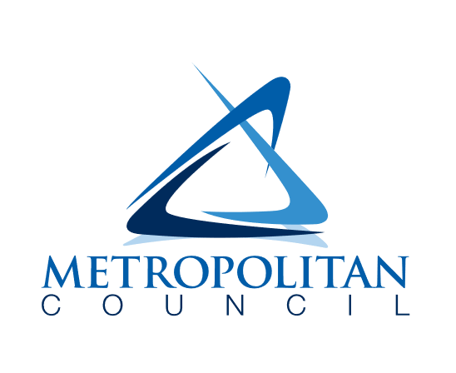
390 Robert Street North
St Paul, MN 55101-1805
651-602-1000
TTY 651-291-0904
public.info@metc.state.mn.us
metrocouncil.org
Follow us on:
twitter.com/MetCouncilNews

facebook.com/MetropolitanCouncil

